

**Major Project Report**

**on**

# “STOCK AND SHOP: A FULL-STACK

# E-COMMERCE SYSTEM USING THE MERN STACK”

### Submitted in partial fulfilment for the requirements of the degree of

**BACHELOR OF COMPUTER APPLICATIONS**

**CENTER FOR DISTANCE & ONLINE EDUCATION CHANDIGARH UNIVERSITY, MOHALI**

**PUNJAB**

**SUBMITTED TO : SUBMITTED BY :**

**Programme Coordinator – BCA Saanvi Suresh Rao Center for Distance s Online Education O23BCA160051 Chandigarh University, Mohali BCA – Batch – Jan 2023 Punjab**



# DECLARATION

I hereby declare that this Project Report titled **"Stock And Shop: A Full-Stack E-Commerce system using the Mern stack"** is an authentic record of my own work carried out during the academic year **2025-2026**, in partial fulfillment of the requirements for the award of the degree of **Bachelor Of Computer Applications** at **Chandigarh University**.

I further declare that the work presented in this report is original and has not been previously submitted in part or full for any other degree,

diploma, or similar award at any other university or institution. All sources of information and help have been duly acknowledged.

**Saanvi Suresh Rao O23BCA160051**

**Bachelor Of Computer Application**

**Center for Distance & Online Education**

**Date:** November 29, 2025

**Place:** Vapi, Gujarat

# ACKNOWLEDGEMENT

I want to sincerely thank everyone who helped me finish my project,

“**Stock And Shop: A Full-Stack E-Commerce system using the Mern stack”** and for their support.

I am extremely grateful to Chandigarh University for giving me the chance to complete this project as a requirement for my Bachelor Of Computer

Application degree. I am grateful to Chandigarh University's academic staff and administration for creating and implementing a thorough program

that gave me the skills and information I needed to finish this work.

I also want to thank the technical support staff for helping to make sure that the learning process runs smoothly.

Lastly, I would like to express my sincere gratitude to my family for their unwavering understanding, encouragement, and support during the

difficult stages of this project.

Saanvi Suresh Rao O23BCA160051

Bachelor Of Computer Applications – CU ONLINE

# ABSTRACT

This major project introduces **"Stock & Shop,"** an e-commerce platform developed to address the process inefficiencies inherent in traditional grocery shopping while providing a secure and scalable online marketplace for groceries, vegetables, and fruits.

The system focuses on establishing a full-stack, dynamic environment for retail, ensuring improved inventory visibility and streamlined transaction processing. The platform is built on the **MERN stack**, utilizing **MongoDB** for flexible product and order data storage, **Express.js** and **Node.js** for a high-performance backend API, and **React** for a dynamic, user-friendly shopping experience.

Key functionalities include secure user authentication, real-time cart management, and a robust **online payment gateway integrated via Stripe**. A critical design element is the focus on **transaction reliability**, ensuring orders are created, and inventory is updated only upon verified, final confirmation of payment receipt.

"Stock & Shop" provides a comprehensive, modern e-commerce solution, significantly enhancing operational proficiency and demonstrating mastery of full-stack development and third-party financial service integration.

# TABLE OF CONTENTS

* **Title Page**
* **Declaration / Bonafide Certificate**
* **Acknowledgement**
* **Abstract**
* **Table of Contents Chapters**
* **Chapter 1: Background**
  + **Project Profile and Objectives**
  + **Scope of the Project**
  + **Existing System Limitations and Proposed Solution**
  + **Technology Used**
* **Chapter 2: System Analysis** 
  + **Study of Requirements**
  + **Feasibility Study**
  + **Hardware and Software Requirements**
  + **System Planning**
* **Chapter 3: System Design**
  + **System Architecture**
  + **ER-Diagram**
  + **Data Flow Diagrams**
  + **Database Design and Schema**
  + **Input And Output Screen Design**
* **Chapter 4: Implementation**
  + **Process Logic of Authentication Module**
  + **Process Logic of Product and Inventory Module**
  + **Process Logic of Payment Gateway**

**Secure Webhook Handler Implementation**

**Order Fulfillment and Cart Clearance Logic**

* + **Code implementation Details**
* **Chapter 5: Testing And Maintenance**
  + **Testing Methodology Adopted**
  + **Test Cases and Expected Results**
  + **System Evaluation and Future Scope**
  + **Cost and Benefit Analysis**
  + **User/Operational Manual**
* ***CONLUSION***

***BIBLIOGRAPHY / REFERENCES***

***APPENDICES***

# CHAPTER – 1 BACKGROUND

**PROJECT PROFILE AND OBJECTIVE:**

The project, titled **"E-COMMERCE SYSTEM USING MERN STACK"** (named **Stock & Shop** in the application), is a robust, full-stack application developed to serve as a modern online platform for purchasing groceries, fresh vegetables, and fruits. The system is architected around the highly scalable **MERN (MongoDB, Express.js, React, Node.js) technology stack**.

**Project Profile**

|  |  |
| --- | --- |
| **DETAIL** | **DESCRIPTION** |
| Project Name | Stock & Shop |
| Domain | E-commerce for Groceries and Inventory Management |
| Architecture | Full-Stack, Three-Tier (MERN) |
| Key Technology | MongoDB, React, Node.js/Express, Stripe Payment Gateway |
| Target Users | Retail Customers and System Administrators |

**Project Objectives**

The core objectives of developing the Stock & Shop E-commerce System are as follows:

1. **To Implement a Scalable MERN Architecture**: To design and develop a high-performance application utilizing a component-based React frontend and a modular Node.js/Express backend, ensuring the system can handle a growing user base and product catalog.
2. **To Ensure Secure and Controlled Access:** To establish a complete user lifecycle management system, including secure authentication, Role-Based Access Control (RBAC) to differentiate Customer and Administrator privileges, and a secure Forgot Password feature utilizing OTP (One-Time Password) email verification.
3. **To Provide Real-Time Inventory Control:** To implement an efficient Admin Dashboard allowing for CRUD (Create, Read, Update, Delete) operations on categories, sub-categories, and products, ensuring accurate and real-time tracking of stock quantity.
4. **To Integrate a Reliable Payment Solution:** To integrate the Stripe Payment Gateway for secure, third-party processing of all online credit/debit card transactions, maintaining strict security and PCI compliance.
5. **To Guarantee Transaction Reliability:** To design and implement the complex secure order fulfillment logic on the backend to ensure that permanent order records are created and customer carts are cleared only after a verified, successful payment signal is received from Stripe.

**Scope of the Project:**

The project scope defines the functional boundaries of the "Stock & Shop" E-commerce System, covering the complete lifecycle from inventory management to order fulfillment using the MERN stack and Stripe.

1. **Authentication and Security:** Includes secure user **Login, Register**, and **Forgot Password** with **OTP** verification. The system implements **Role-Based Access Control (RBAC)** to distinguish between Customer and Administrator privileges.
2. **Inventory Management:** The Administrator module is fully in scope, enabling **CRUD (Create, Read, Update, Delete)** operations on all **Groceries, Categories, and Sub-Categories**. The system tracks and updates **real-time stock quantity**.
3. **Customer Shopping Experience:** The scope covers the user interface for product **browsing, searching, cart management**, and the ability to save multiple **shipping addresses**.
4. **Secure Payment and Fulfillment:** The system integrates the **Stripe API** to initiate online payment sessions. Crucially, the backend implements **secure server-to-server confirmation logic** to ensure orders are created and the customer's cart is cleared **only** upon verified payment success.

**Existing System Limitations and Proposed Solution:**

This section analyzes the shortcomings of traditional or older retail systems, which the Stock & Shop E-commerce platform is designed to address through its modern technology stack.

**A. Limitations of the Existing/Manual System**

|  |  |
| --- | --- |
| **LIMITATION** | **DESCRIPTION** |
| **Inaccurate Inventory** | Manual tracking of grocery and produce stock is prone to human error, leading to inaccurate availability displayed to the customer. |
| Limited Accessibility | Physical stores or basic websites are not accessible 24/7, restricting sales opportunities and customer convenience. |
| Payment Insecurity | Systems relying on cash on delivery or non-integrated payment methods lack security and real-time transaction verification, posing fraud risks. |
| Lack of Data Centralization | Customer data, orders, and sales history are often scattered, making trend analysis and efficient resource planning difficult. |

**B. The Proposed Solution**

The "Stock & Shop" E-commerce System overcomes these limitations by implementing a modern, integrated, and scalable solution:

1. Real-Time Data Management: The MERN Stack (MongoDB) provides a centralized database for all inventory, customer, and order data, enabling the Admin to view and update stock quantities in real-time.
2. 24/7 Accessibility: The React frontend provides a dynamic, accessible online platform that operates continuously, significantly expanding the market reach.
3. Secure Financial Transactions: Integration with the Stripe Payment Gateway offloads sensitive card processing, ensuring PCI compliance and providing instant, verified payment confirmation via a secure server-to-server connection.
4. Automated Fulfillment: The backend logic automatically manages order creation, inventory updates, and cart clearance upon verified payment, maximizing efficiency and minimizing human error.

**Technology Used:**

The "Stock & Shop" E-commerce System is a Full-Stack application built on the MERN technology stack, supplemented by the Stripe Payment Gateway. This modern architecture was chosen for its flexibility, scalability, and ability to handle high-performance web applications.

|  |  |  |
| --- | --- | --- |
| **COMPONENT** | **TECHNOLOGY** | **ROLE IN THE SYSTEM** |
| M | MongoDB | The **NoSQL Database** used for flexible and scalable data storage. It manages all application data, including user profiles, product catalogs, and order records. |
| E | Express.js | The **Web Application Framework** for Node.js. It handles routing, middleware, and API endpoints, forming the robust backbone of the server. |
| R | React | The **JavaScript Library** used to build the dynamic, component-based user interface (UI) for both the Customer shopping experience and the Administrator dashboard. |
| N | Node.js | The **JavaScript Runtime Environment** that executes the Express.js server logic. It enables fast, non-blocking I/O operations necessary for a high-traffic E-commerce API. |
| Payment | Stripe API | The integrated third-party service that securely manages all credit/debit card transactions and provides the necessary **webhook** signals for reliable order fulfillment. |

**Development Tools and Libraries**

The project leverages several critical tools beyond the core stack:

* **JWT (JSON Web Tokens):** Used for secure, stateless user authentication and session management.
* **Bcrypt:** Utilized for secure hashing of user passwords before storage in MongoDB.
* **Stripe CLI:** Essential for local development, enabling the simulation of live webhook events on the local machine for testing the order fulfillment logic.
* **NodeMailer:** Used for sending the **OTP (One-Time Password)** via email during the Forgot Password process.

# CHAPTER – 2

# SYSTEM ANALYSIS

# Study of Requirements

The Study of Requirements defines the functional, non-functional, and operational needs of the “Stock & Shop” E-commerce System. This ensures that the system aligns with user expectations, performance goals, security needs, and platform constraints. The requirements were analyzed from the perspectives of customers, administrators, and system behavior, forming the foundation for all design and implementation activities.

**A. Functional Requirements**

Functional requirements define *what the system must do*. These are directly derived from the objectives of the Stock & Shop platform.

**1. User Authentication and Authorization**

* Secure User Registration and Login functionality.
* Role-Based Access Control (RBAC) distinguishing **Customer** and **Admin** users.
* Forgot Password workflow using OTP email verification.
* Authenticated session handling using JWT tokens.

**2. Product and Inventory Management (Admin Module)**

* CRUD operations for Categories, Sub-categories, and Products.
* Real-time updating of product stock quantities.
* Uploading product images, setting prices, descriptions, and category associations.
* Dashboard displaying inventory status.

**3. Customer Shopping Experience (User Module)**

* Product browsing, searching, and filtering.
* Add-to-cart, update quantity, and remove-from-cart functionalities.
* Management of multiple shipping addresses.
* Viewing order history and order details.

**4. Order Management and Payment Integration**

* Creating a temporary order session before payment.
* Integration with Stripe for secure payment processing.
* Receiving secure **webhook events** from Stripe.
* Creating final order records only after verified payment success.
* Auto-clearing the user's cart upon successful payment.

**B. Non-Functional Requirements**

Non-functional requirements ensure performance, availability, reliability, and ease of use.

**1. Performance Requirements**

* The system must handle multiple concurrent user sessions.
* API responses must be optimized using asynchronous, non-blocking Node.js operations.
* Database queries must be index-optimized for faster reads.

**2. Security Requirements**

* Passwords must be encrypted using Bcrypt.
* JWT-based session authentication ensures secure access.
* Stripe ensures PCI-compliant payment processing.
* Sensitive logic (order creation, inventory update) executed **only** on secure server-side webhook confirmation.

**3. Reliability Requirements**

* Webhook handler must ensure idempotency to prevent duplicate orders.
* MongoDB collections must guarantee atomic updates on inventory count.
* The application must ensure uptime with minimal failure points.

**4. Usability Requirements**

* Intuitive navigation for both customer and admin dashboards.
* Mobile-responsive UI using React components.
* Clear visual feedback for cart operations and checkout flow.

**5. Scalability Requirements**

* MERN architecture allows horizontal scaling of backend and database.
* React frontend supports modular expansion for future features.

**C. User Requirements**

User requirements define what **end users expect** from the system.

**Customer Requirements**

* Ability to create an account and login securely.
* Browse products easily with clear categories.
* Add items to cart and complete payments online.
* Track order status and view past orders.

**Administrator Requirements**

* Ability to manage inventory in real time.
* Add, update, or delete categories and products.
* Monitor product availability and update stock accordingly.
* View and manage customer orders.

**D. System Requirements**

These specify the expected system behavior and constraints.

* The application must be accessible 24/7 through the internet.
* Backend must expose RESTful API endpoints for all operations.
* MongoDB must handle structured and unstructured product data efficiently.
* The system must integrate third-party services (Stripe, NodeMailer) without compromising performance.

**Feasibility Study**

The feasibility study evaluates whether the “Stock & Shop” E-commerce System can be successfully developed and operated using the MERN stack and Stripe payment integration. It covers technical, operational, and economic aspects to ensure that the proposed solution is practical, achievable, and beneficial.

**A. Technical Feasibility**

The technologies selected for the project—MongoDB, Express.js, React, Node.js, and Stripe—are modern, well-documented, and widely used for scalable web applications. The MERN stack provides high performance, non-blocking operations, and flexible data handling, making it technically feasible to implement real-time inventory updates, authentication workflows, and payment processing. All required tools and development environments are freely accessible and supported by extensive online resources, ensuring smooth project development.

**B. Operational Feasibility**

The system addresses the limitations of traditional grocery shopping by providing 24/7 accessibility, real-time stock visibility, and secure online payments. The customer interface is designed for easy browsing, cart management, and checkout, while the admin dashboard simplifies product

and inventory management. The solution is practical for real-world use, supports seamless online ordering, and can be operated by both customers and administrators without specialized training.

**C. Economic Feasibility**

The project is economically viable as it uses open-source technologies that eliminate licensing costs. Tools such as MongoDB, Node.js, React, and Express are completely free to use. Stripe follows a pay-as-you-go model, which means there are no upfront charges for integration or testing. The overall development and maintenance cost remains low, making the system cost-effective for deployment, scaling, and long-term use.

**Hardware And Software Requirements**

This section outlines the minimum hardware and software resources required to develop and operate the “Stock & Shop” E-commerce System. Since the application is MERN-based and uses Stripe for payment integration, the requirements are lightweight and suitable for modern development environments.

**A. Hardware Requirements**

**For Development**

* **Processor:** Intel i5 or equivalent
* **RAM:** 8 GB (minimum)
* **Storage:** 20 GB free space
* **System:** Windows / macOS / Linux

**For Deployment (Server)**

* **Processor:** Dual-core CPU
* **RAM:** 4–8 GB
* **Storage:** SSD preferred
* **Network:** Stable broadband connection

**B. Software Requirements**

**Backend**

* Node.js
* Express.js
* MongoDB
* Stripe API
* Postman (for API testing)

**Frontend**

* React
* HTML, CSS, JavaScript
* Axios for API requests

**Development Tools**

* VS Code
* Git and GitHub
* MongoDB Compass
* Stripe CLI
* npm packages (JWT, Bcrypt, Nodemailer, etc.)

**System Planning**

System planning involves defining the structure and workflow of the Stock & Shop platform to ensure smooth development and efficient operation.

1. **Modular Architecture:**

The system is divided into modules such as Authentication, Product Management, Cart, Orders, and Payment Integration for easier development and maintenance.

1. **Three-Tier MERN Structure:**
   * Frontend (React): Handles UI and customer interactions.
   * Backend (Node/Express): Manages business logic and API routes.
   * Database (MongoDB): Stores users, products, orders, and inventory data.
2. **API Planning:**

REST-based endpoints were planned for user actions, admin operations, cart updates, and order processing.

1. **Database Planning:**  
   Collections were planned for Users, Products, Categories, Orders, and Cart Items.
2. **Payment Workflow Planning:**  
   Stripe Checkout and Webhook handling were designed to ensure secure order creation only after valid payment confirmation.

# CHAPTER – 3

# SYSTEM DESIGN

# System Design defines the structural, architectural, and data-oriented blueprint of the “Stock & Shop” E-commerce System. The purpose of this chapter is to illustrate how different components of the application interact, how data flows between modules, and how the system ensures secure and efficient operations.

# System Requirements

# The “Stock & Shop” application follows a Three-Tier MERN Architecture, ensuring modularity, scalability, and efficient separation of concerns.

# A. Presentation Layer (Frontend – React)

# Displays categories, products, cart, checkout, and admin dashboard.

# Manages user interactions through reusable components.

# Communicates with backend APIs using Axios.

# Implements client-side routing for smooth navigation.

# B. Application Layer (Backend – Node.js + Express.js)

# Handles all business logic for authentication, products, orders, and payments.

# Validates user requests and enforces role-based permissions.

# Connects to Stripe for payment session creation and webhook verification.

# Generates JWTs and processes encrypted credentials.

# C. Data Layer (Database – MongoDB)

# Stores Users, Products, Categories, Orders, and Cart items.

# Maintains real-time stock quantities.

# Ensures consistency during order confirmation via secure server-side logic.

# Data Flow Summary: React → Express API → MongoDB Stripe Payment → Webhook → Express → MongoDB (Order creation)

**ER Diagram (Entity–Relationship Overview)**

The ER model of the system identifies key entities and relationships required for managing the e-commerce workflow.

Major Entities

1. **User**
   * Fields: name, email, password, role, addresses
   * Relationship: User → Orders (1-to-many)
2. **Product**
   * Fields: name, categoryId, price, stock, image
   * Relationship: Category → Products (1-to-many)
3. **Category / Sub-category**
   * Grouping for products
   * Helps streamline admin management and product filtering
4. **Order**
   * Fields: userId, items, totalAmount, paymentStatus, timestamp
   * Relationship: Order → User (many-to-1)
5. **Cart**
   * Temporary storage of selected products before checkout
   * Related to User (1-to-1)

**High-Level Relationships**

* User places Orders
* User has Cart
* Category contains Products
* Order contains multiple Products

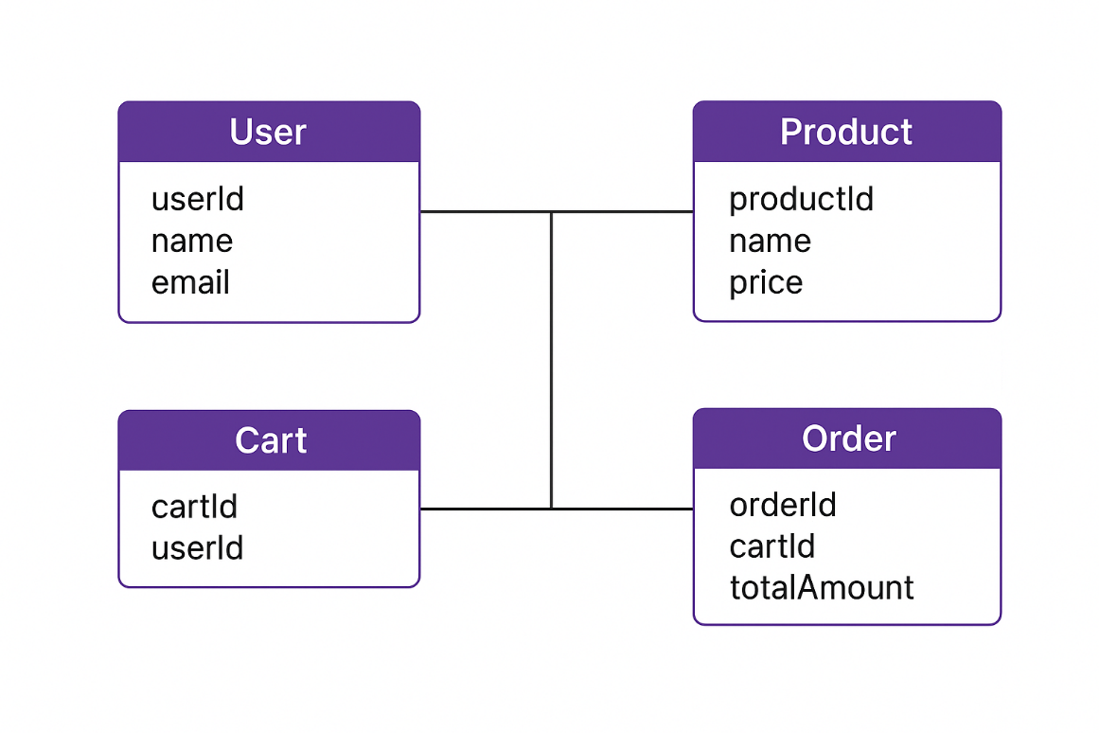

**Figure (a) : Entity Relationship Diagram of**

**Stock and Shop**

**Data Flow Diagrams (DFD)**

DFDs illustrate how data moves within the system.

**A. Level 0 DFD – Context Diagram**

Shows the system as a single process interacting with:

* Customer
* Administrator
* Stripe Payment Gateway

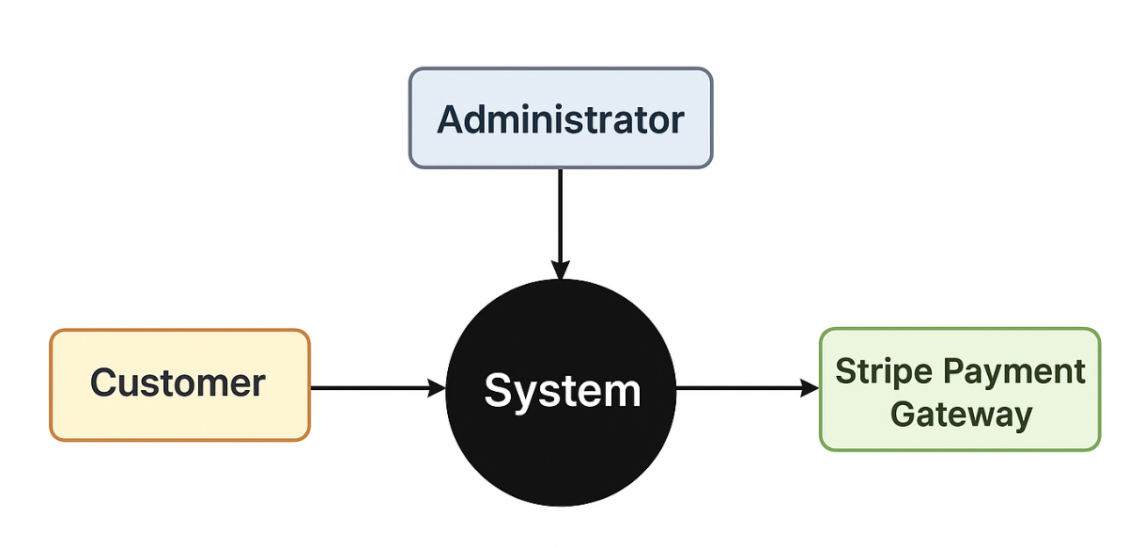

**Figure (b) : Level 0 DFD**

**B. Level 1 DFD – Expanded Processes**

1. User Process:  
   Login → Browse Products → Add to Cart → Checkout
2. Admin Process:  
   Manage Categories → Manage Products → Update Stock
3. Payment Process:  
   Initiate Payment → Stripe Checkout → Webhook Response → Order Creation

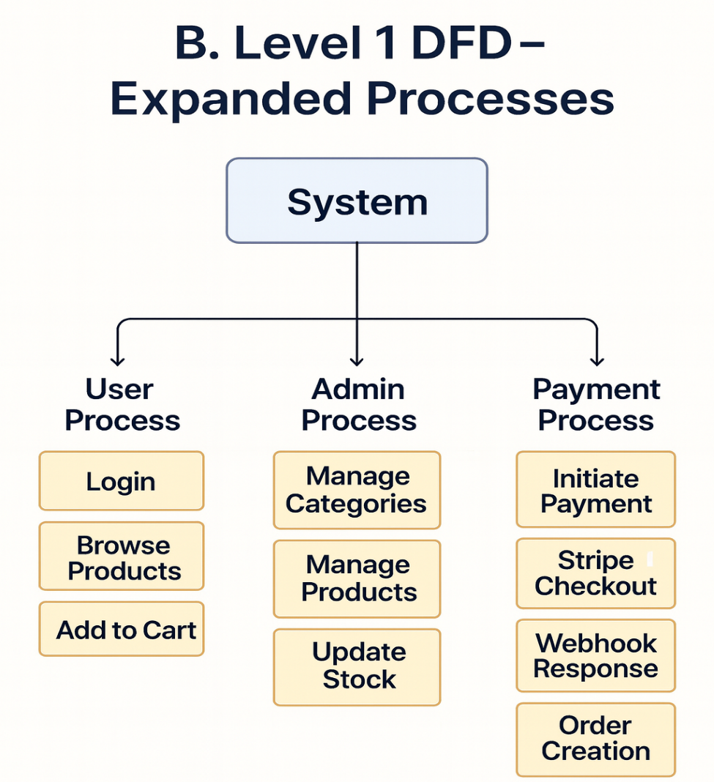

**Figure (c) : Level 1 DFD**

**C. Level 2 DFD – Deep Payment Flow**

* Backend creates payment session
* Stripe processes card
* Stripe webhook confirms payment
* Backend updates inventory and creates order
* Cart items are cleared

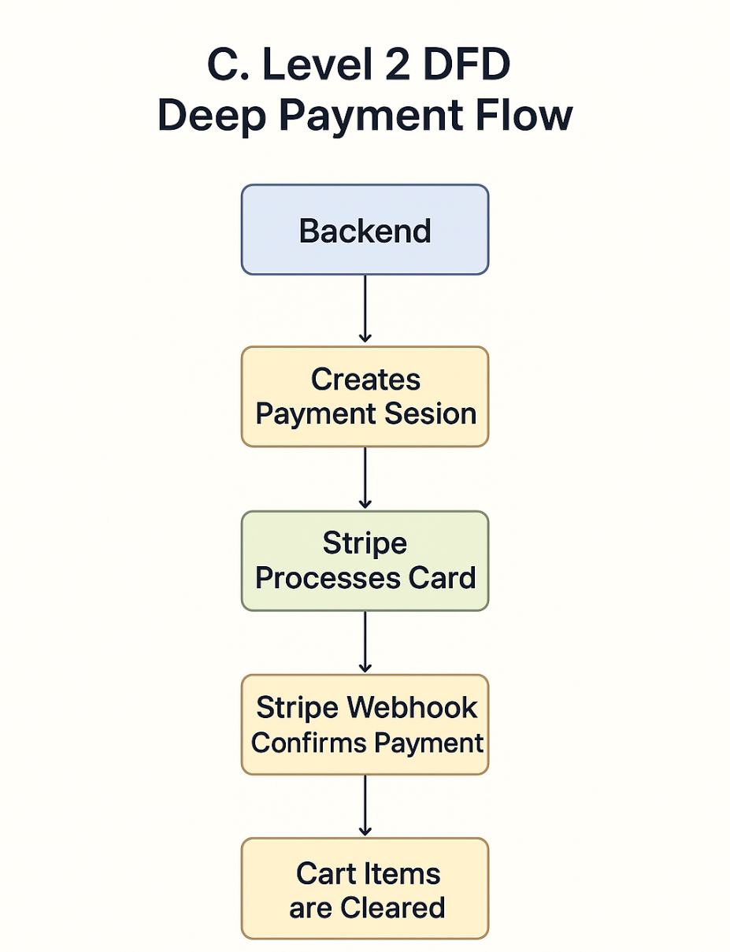

**Figure (d) : Level 2 DFD**

**Database design and schema**

The database uses a collection-based schema, ideal for flexible e-commerce data.

**Main Collections**

1. **Users**
   * name, email, role, hashed password, addresses
2. **Products**
   * title, description, category, stock, price, image URL
3. **Categories / Subcategories**
   * name, parentCategoryId (optional)
4. **Orders**
   * userId, orderItems, totalAmount, paymentIntentId, orderStatus
5. **Cart Items**
   * userId, productId, quantity

**Design Principles**

* Use of ObjectId references for relationships
* Inventory decremented only after verified payment
* Orders linked to both user and Stripe payment session
* Timestamped records for tracking and sorting

**Input and Output Screen Design**

The screen designs define the visual interaction points for both customers and administrators.

**A. Customer Screens**

* Home Page: Categories and product listings
* Product Page: Product details, stock, and Add-to-Cart option
* Cart Page: Update quantity, remove items
* Checkout Page: Payment initiation via Stripe
* Order History: View previous orders

**B. Admin Screens**

* Dashboard: Summary of products and stock
* Add/Edit Product: Form-based product management
* Category Management: CRUD operations
* View Orders: Complete order details and statuses

**C. Output Screens**

* Payment Success Screen
* Order Confirmation Screen
* Error or Validation Messages

# CHAPTER – 4

# IMPLEMENTATION

This chapter describes the practical implementation of the **“Stock & Shop” E-Commerce System**, developed using the MERN stack. The implementation covers authentication, admin inventory management, customer modules, secure payment gateway integration, and backend business logic.

# Process Logic of Authentication Module

# The Authentication Module handles user registration, login, and secure password reset using OTP. It also identifies whether the user is an Admin or Customer and routes them accordingly.

# 4.1.1 Registration Logic

# Process:

# User enters name, email, and password.

# Backend validates email uniqueness.

# Password is hashed using bcrypt.

# New user is saved with default role “customer”.

# 

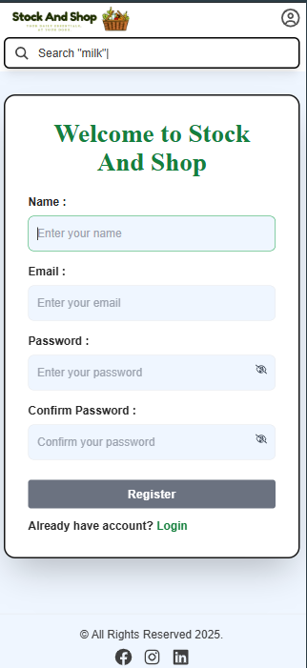

**Figure 4.1: User Registration Page**

**4.1.2 Login Logic**

Process:

* User enters credentials.
* Server verifies hashed password.
* JWT token is generated.
* If role = Admin → redirect to Admin Dashboard.
* If role = Customer → redirect to User Homepage

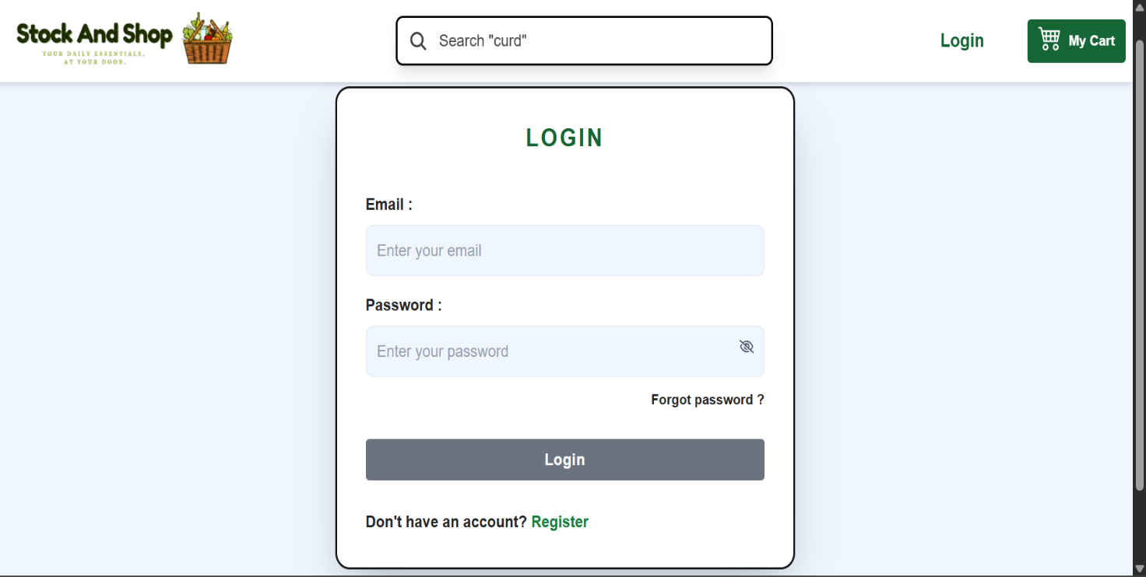

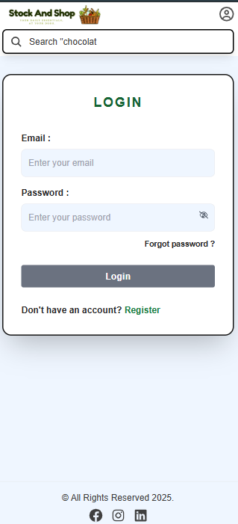

**Figure 4.2: User Login Page**

**4.1.3 Forgot Password (OTP) Logic**

Process:

* User enters registered email.
* OTP is generated and emailed using **Nodemailer**.
* User verifies OTP.
* System allows new password creation.

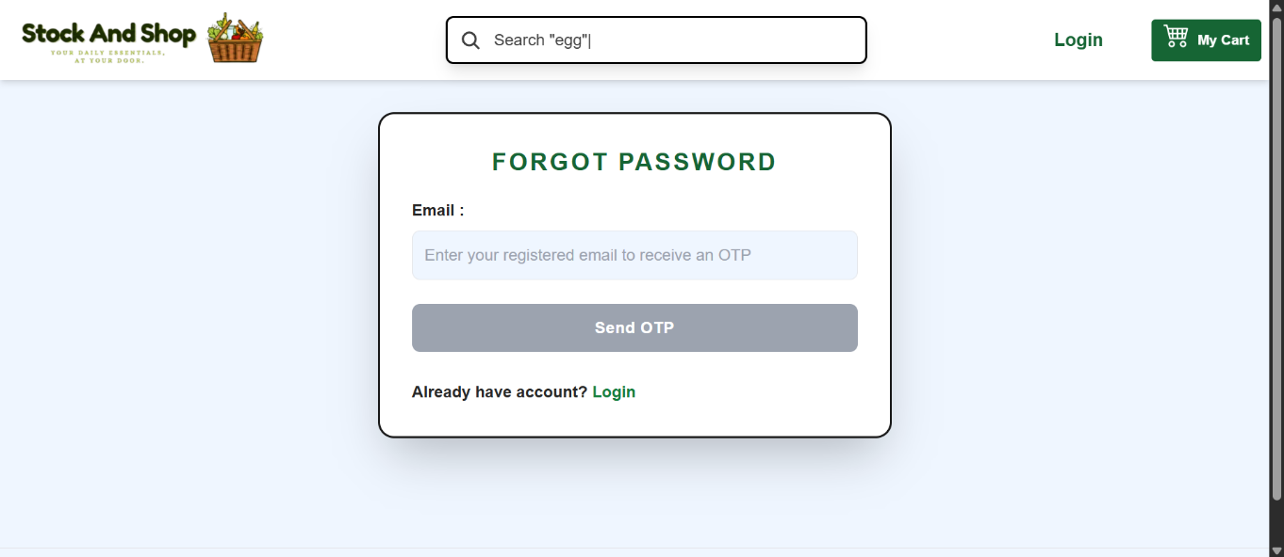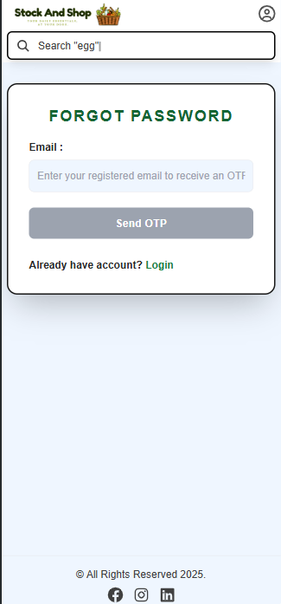

**Figure 4.3: Forgot Password**

**4.1.4 Authenticated User Details Page**

Both Admin and Customer have profile pages displaying personal details.

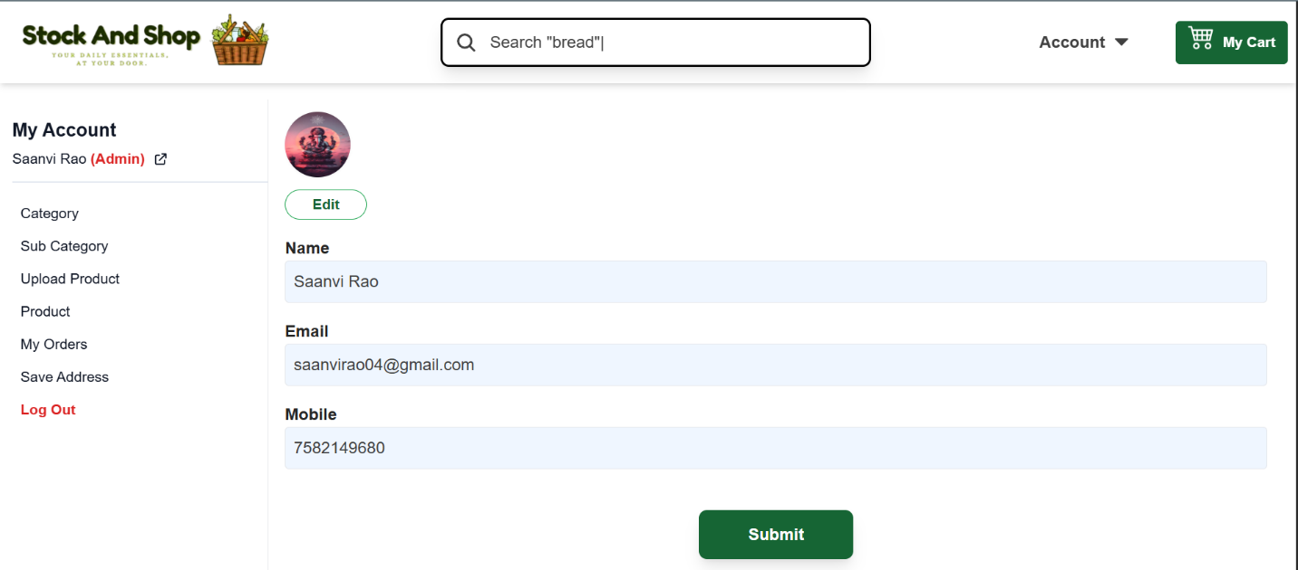

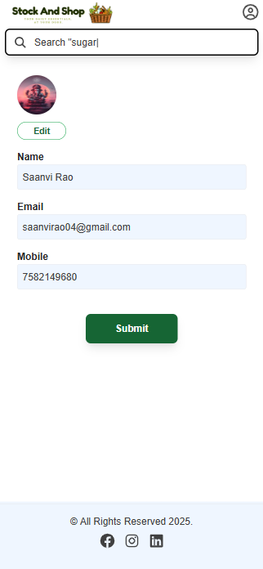

**Figure 4.4: Admin Profile Page**

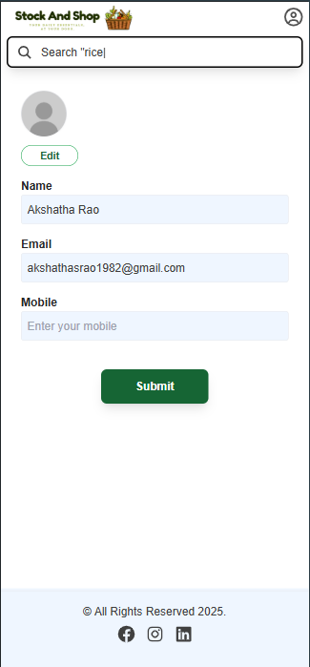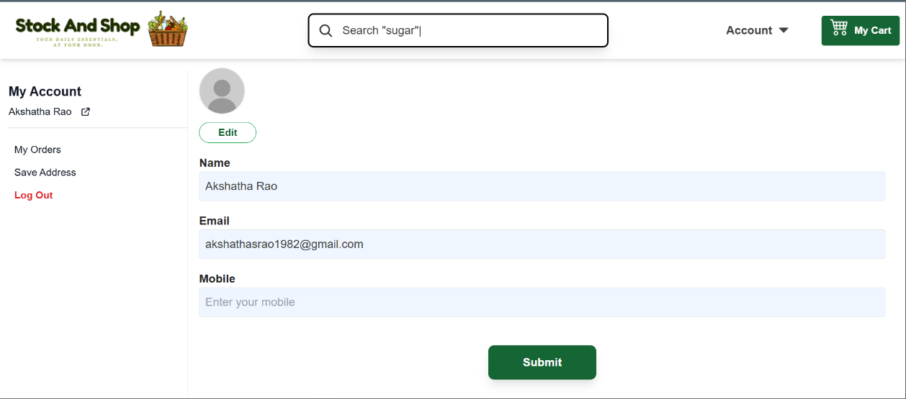

**Figure 4.5: Customer Profile Page**

**4.2 Process Logic of Product & Inventory Module (Admin)**

This module is accessible only to the **Administrator** and provides complete control over categories, sub-categories, products, and inventory stock.

**4.2.1 Category Management**

**Process:**

* Admin enters category name and image.
* Category is stored in MongoDB.
* Categories are displayed dynamically during product upload.

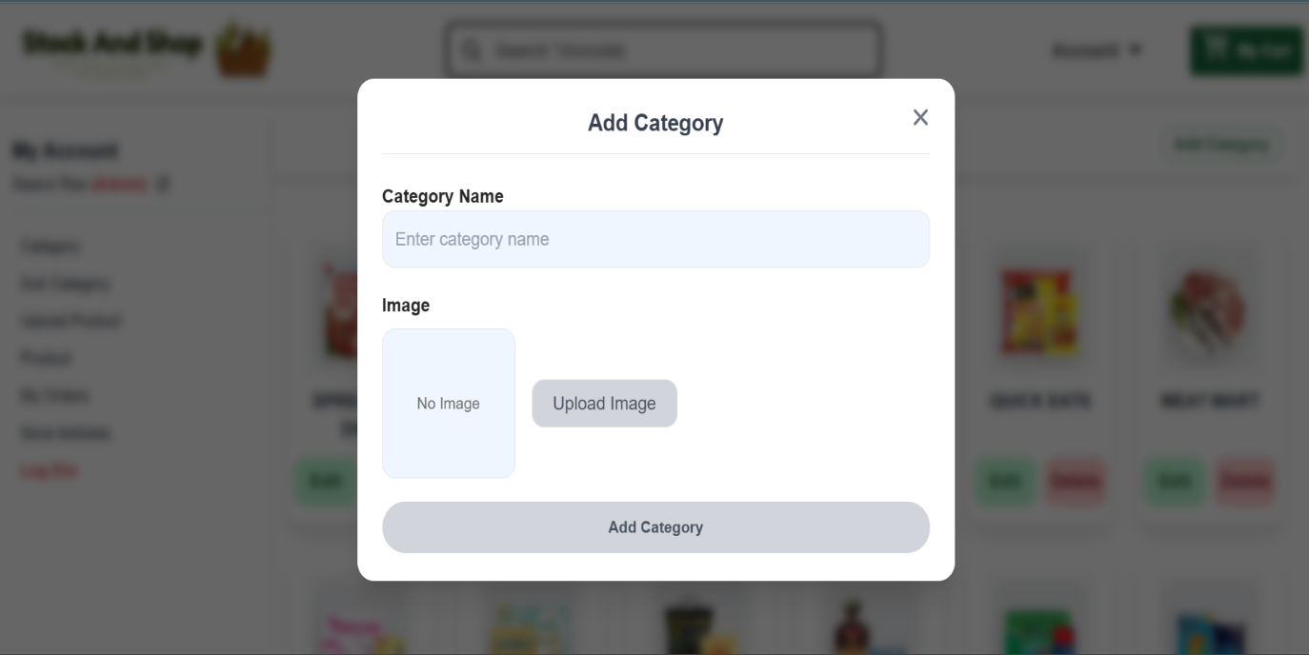

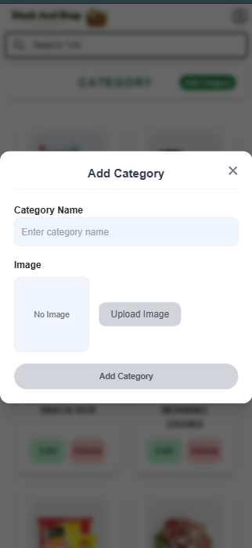

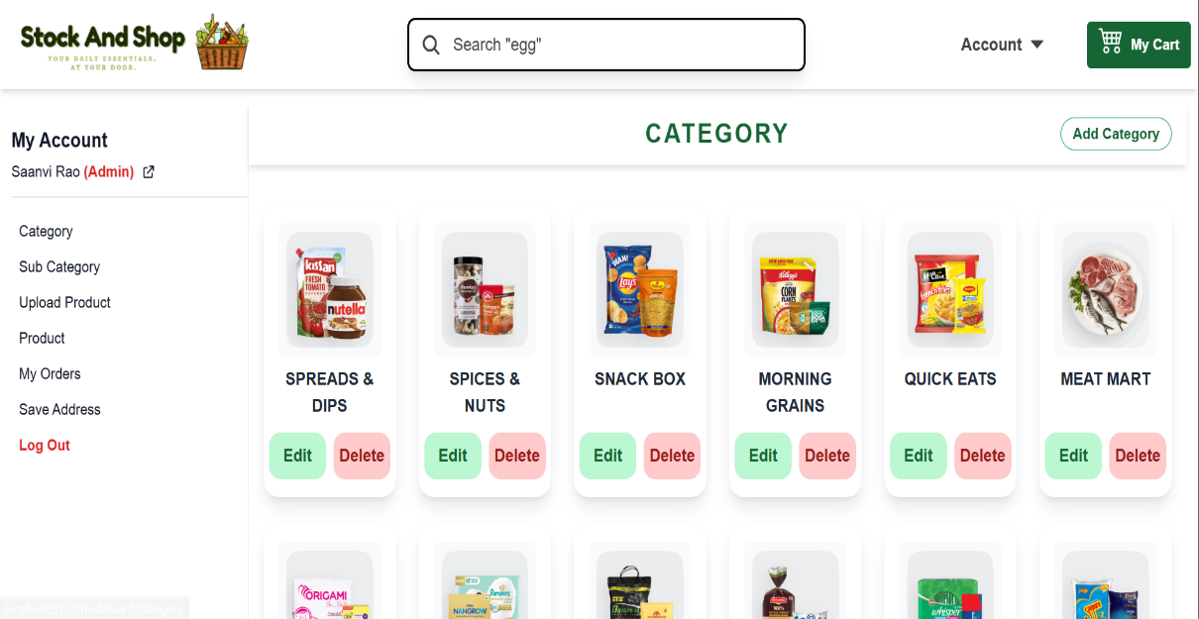**Figure 4.6: Admin – Add Category Page**

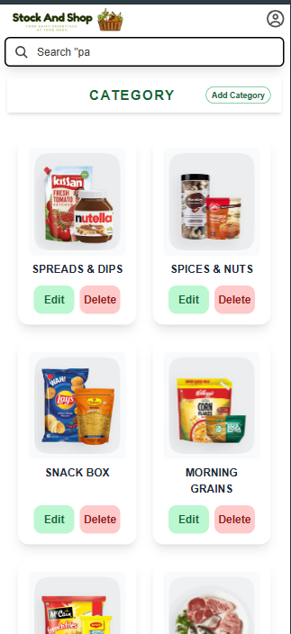

**Figure 4.7: Admin – Category List Page**

**4.2.2 Sub-Category Management**

**Process:**

* Admin selects a category.
* Adds sub-category name and image.
* Sub-category stored with reference to parent category.

### 

**Figure 4.8: Admin – Add Sub-Category Page**

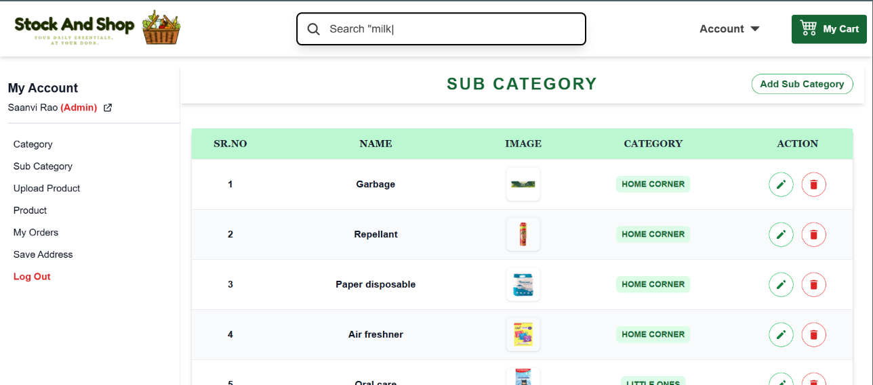

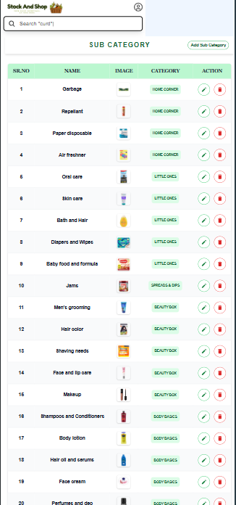

**Figure 4.9: Admin – Sub-Category List Page**

**4.2.3 Product Upload & Listing**

**Process:**

* Admin selects Category → Sub-Category.
* Enters product details.
* Uploads product image.
* Product stored with category and sub-category references.

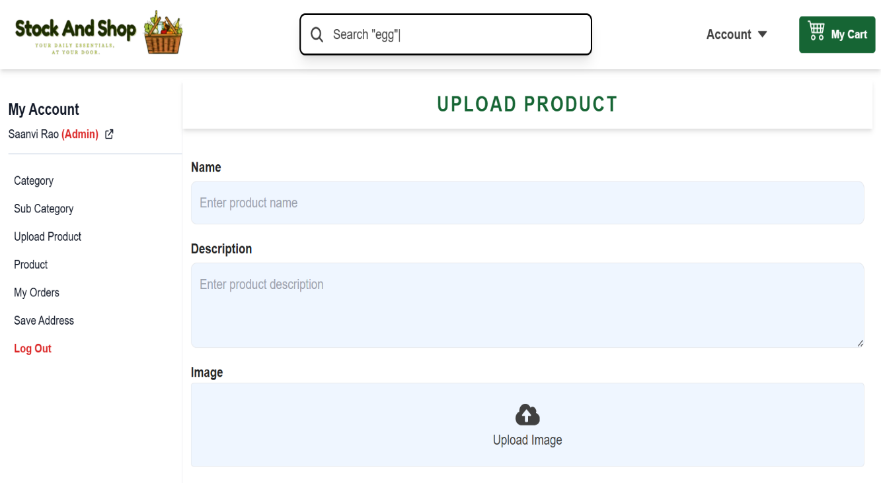

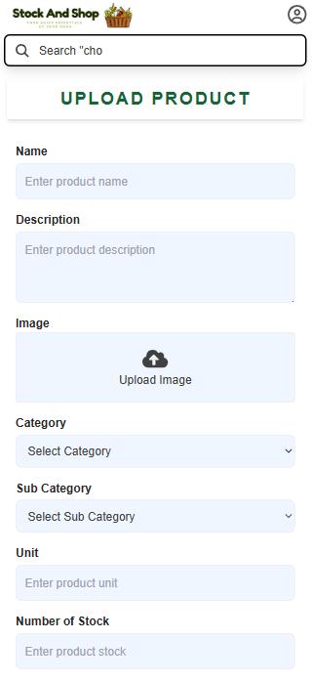

**Figure 4.10: Admin – Upload Product Page**

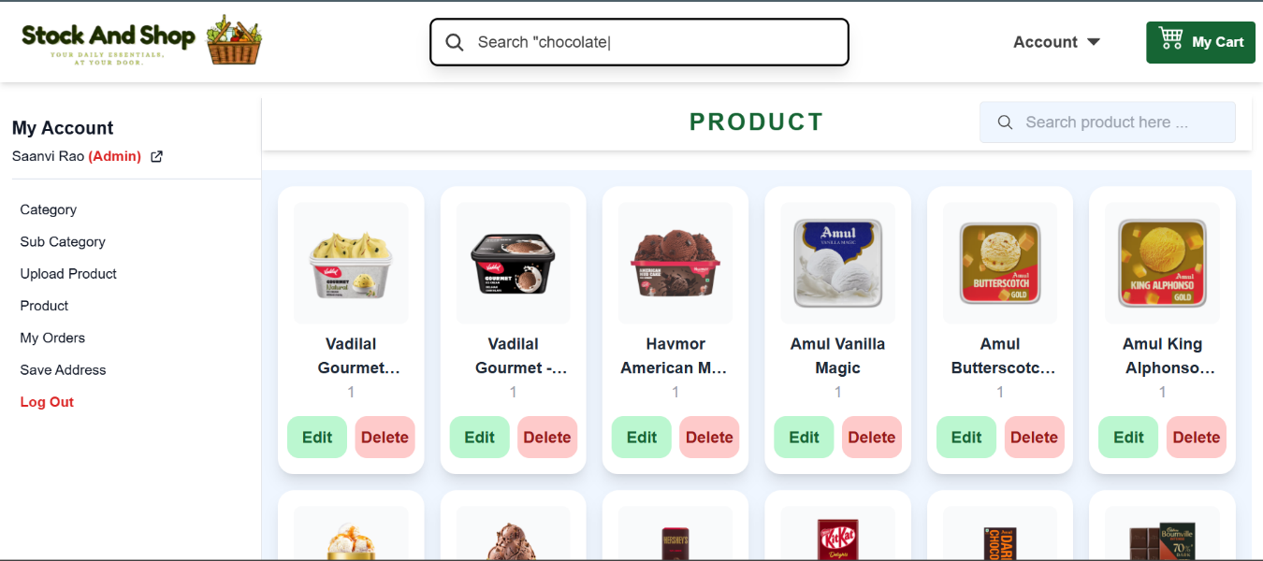

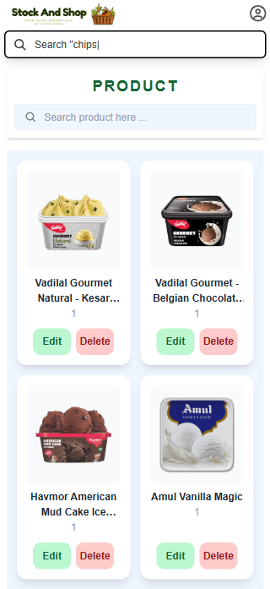

**Figure 4.11: Admin – Product Page**

**4.2.4 Admin – Orders & Addresses**

Admin can view:

* All customer orders
* Saved delivery addresses

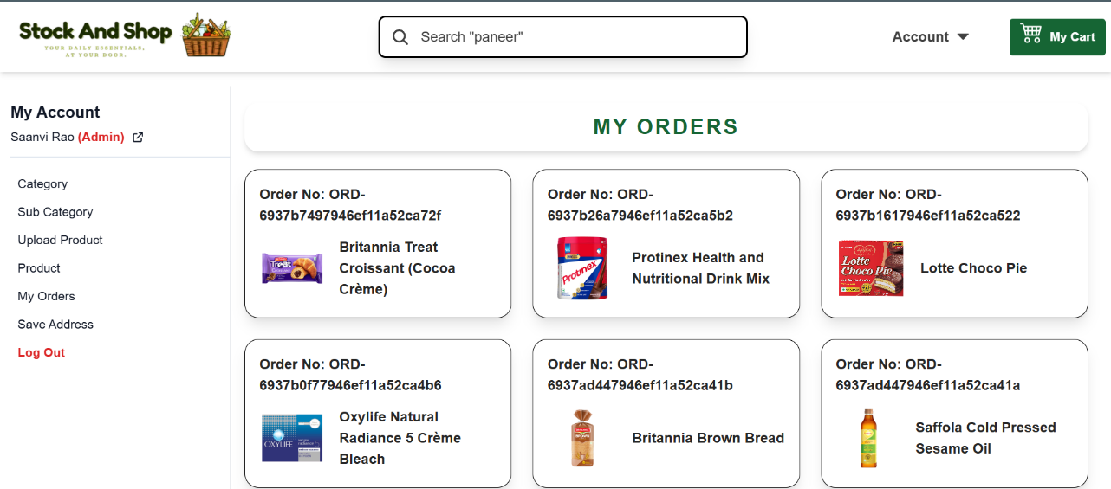

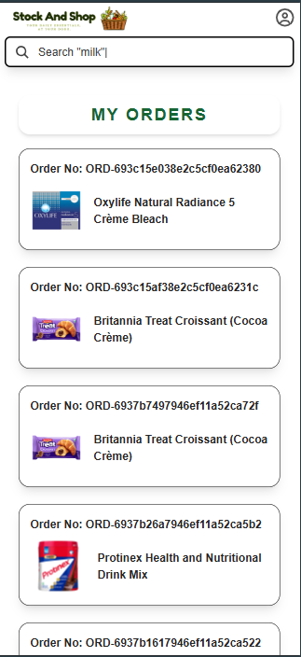

**Figure 4.12: Admin – My Orders Page**

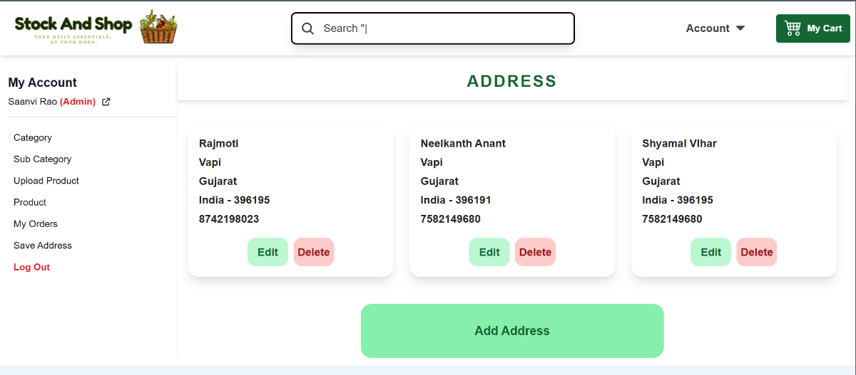

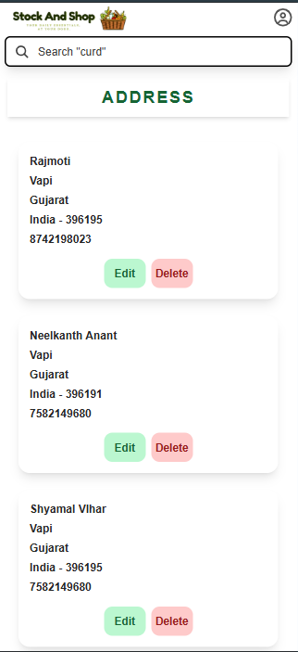

**Figure 4.13: Admin – Saved Addresses Page**

**4.3 Process Logic of Payment Gateway (Stripe Integration)**

The system integrates **Stripe Payment Gateway** to ensure secure, reliable, and verified online transactions.

**4.3.1 Cart Management (Customer)**

**Process:**

* Customer adds products to cart.
* Cart quantity updates dynamically.
* Cart data stored in MongoDB.

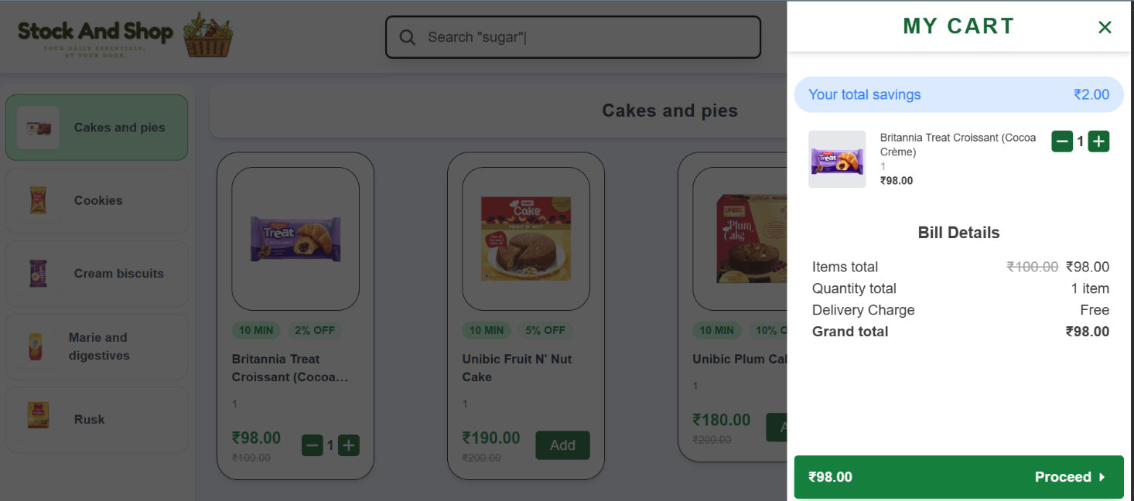

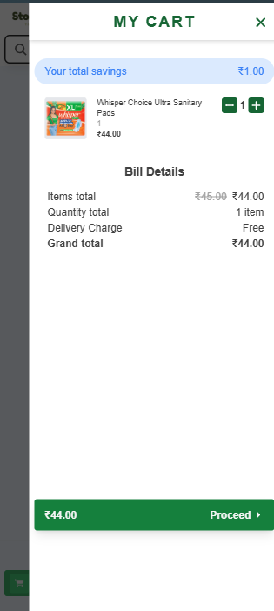

**Figure 4.14: Customer – My Cart Page**

**4.3.2 Checkout Flow**

**Process:**

* User clicks checkout.
* Backend prepares line items.
* Stripe Checkout Session is created.
* User redirected to Stripe payment page.

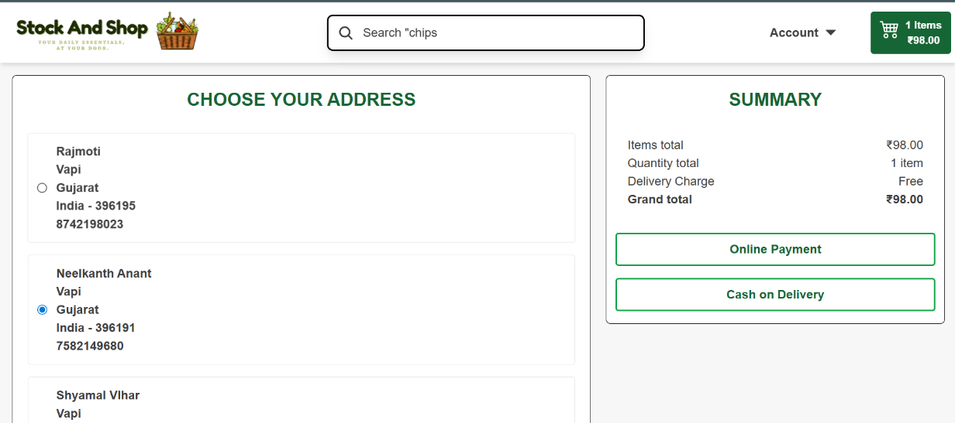

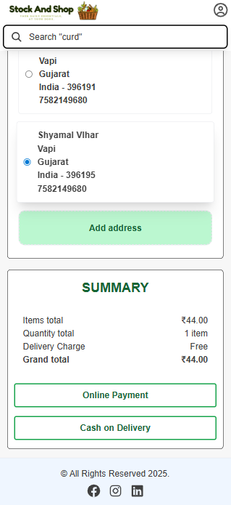

**Figure 4.15: Checkout Page**

**4.3.3 Secure Webhook Handler Implementation**

After payment completion, Stripe sends a webhook to the backend.

**Process:**

* Stripe verifies payment.
* Sends event to /api/webhook/stripe.
* Backend validates webhook signature.
* Metadata (userId, cartId) is extracted.
* Order Fulfillment Logic is triggered.

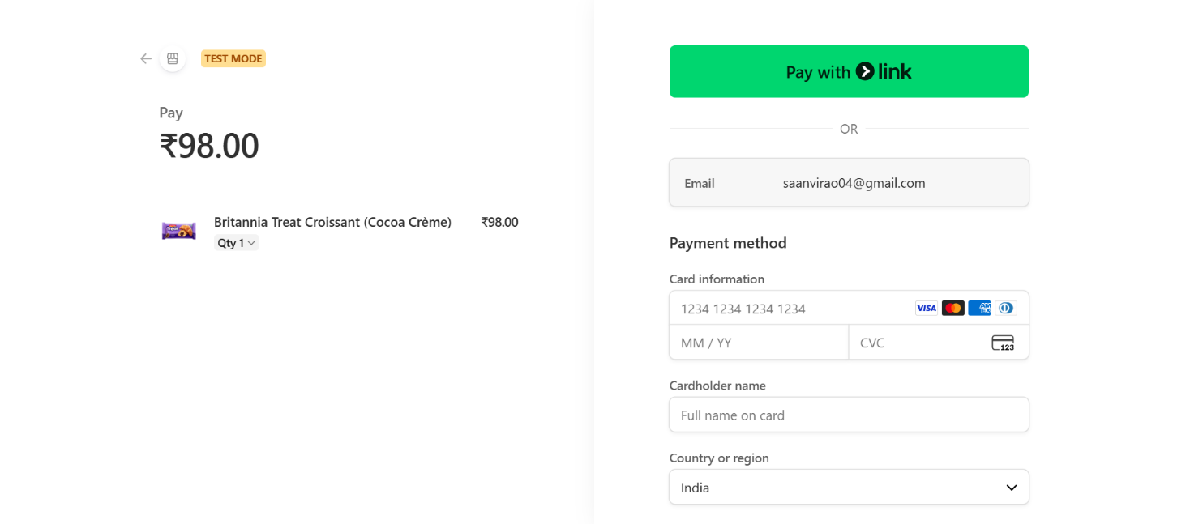

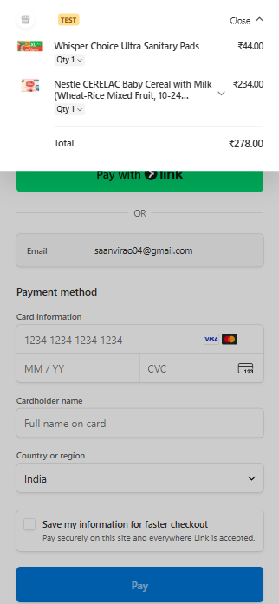

**Figure 4.16: Stripe Page**

**4.3.4 Order Fulfillment & Cart Clearance Logic**

**Process:**

* Order record created in database.
* Product stock is updated.
* Cart items are cleared.
* Order confirmation response sent to user.

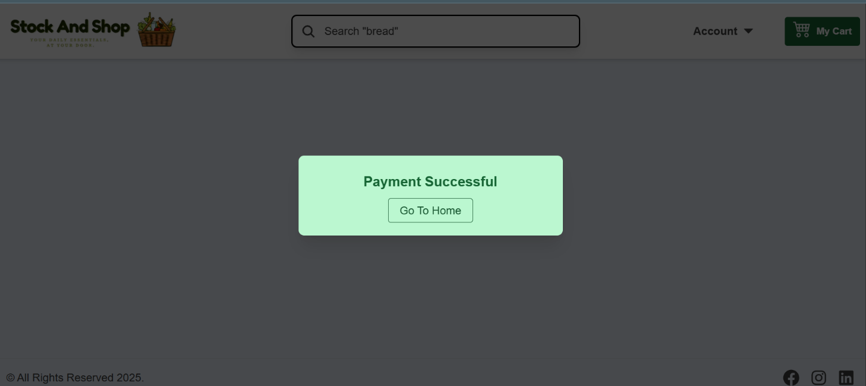

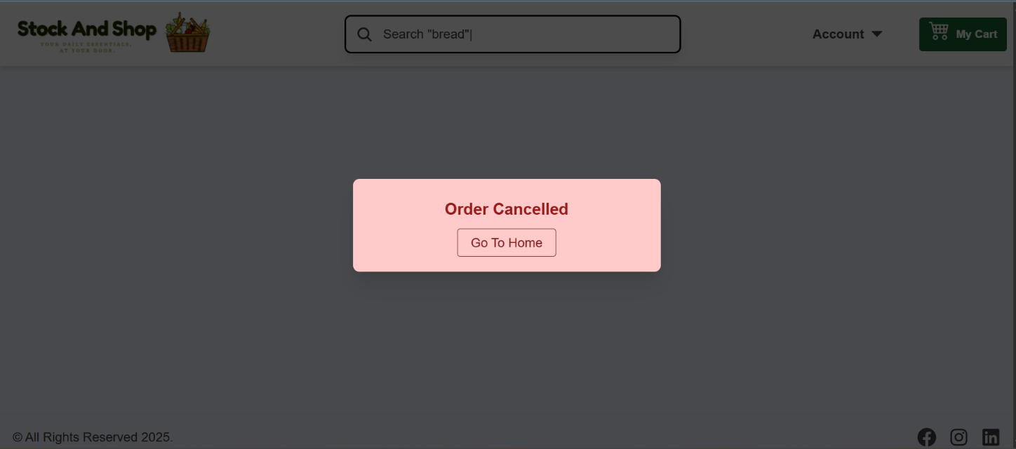

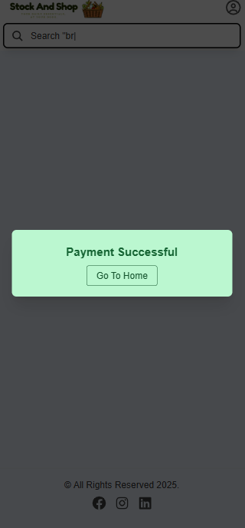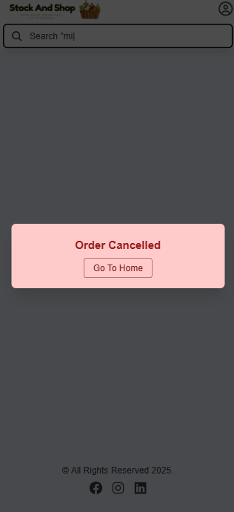

**Figure 4.17: Order Confirmation Page**

**4.4 Code Implementation Details**

This section highlights the core code files used in implementing authentication, inventory management, cart operations, and payment processing. Only essential files are included to maintain clarity.

**4.4.1 Authentication Code**

* **user.controller.js** – Handles user registration, login, and OTP-based password reset
* 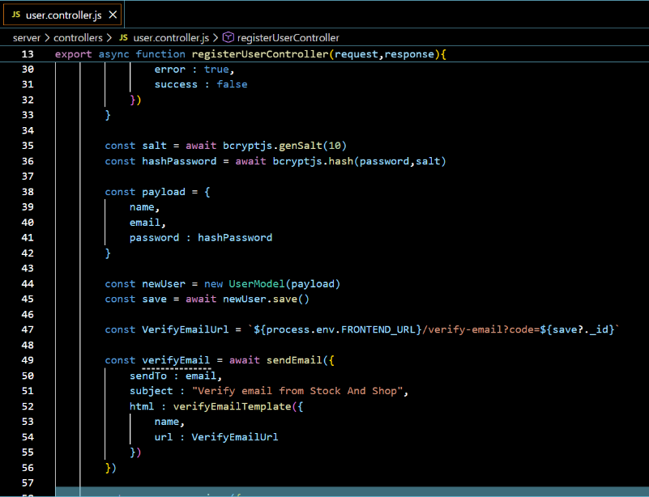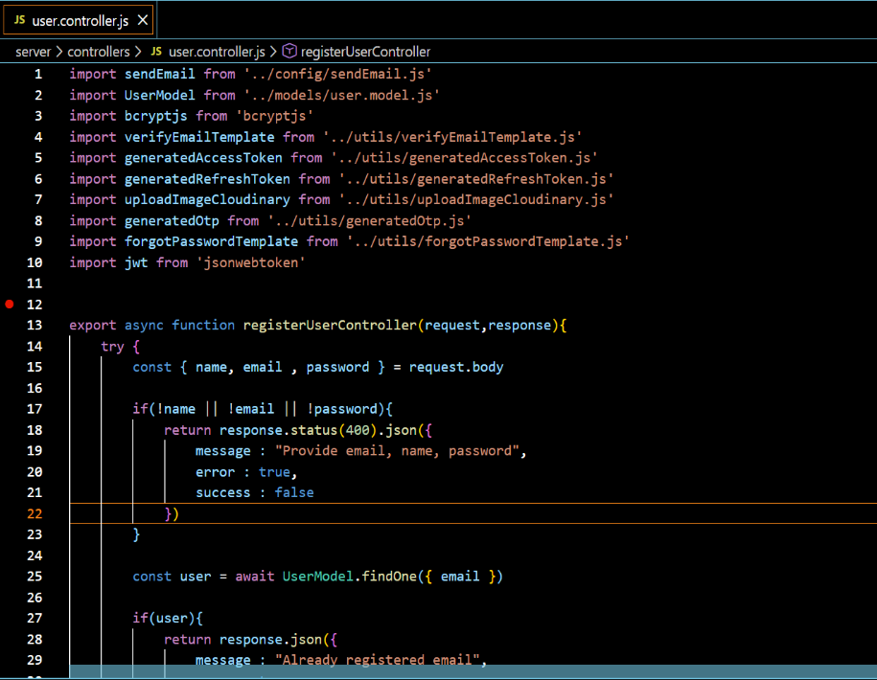**auth.js** – JWT authentication middleware

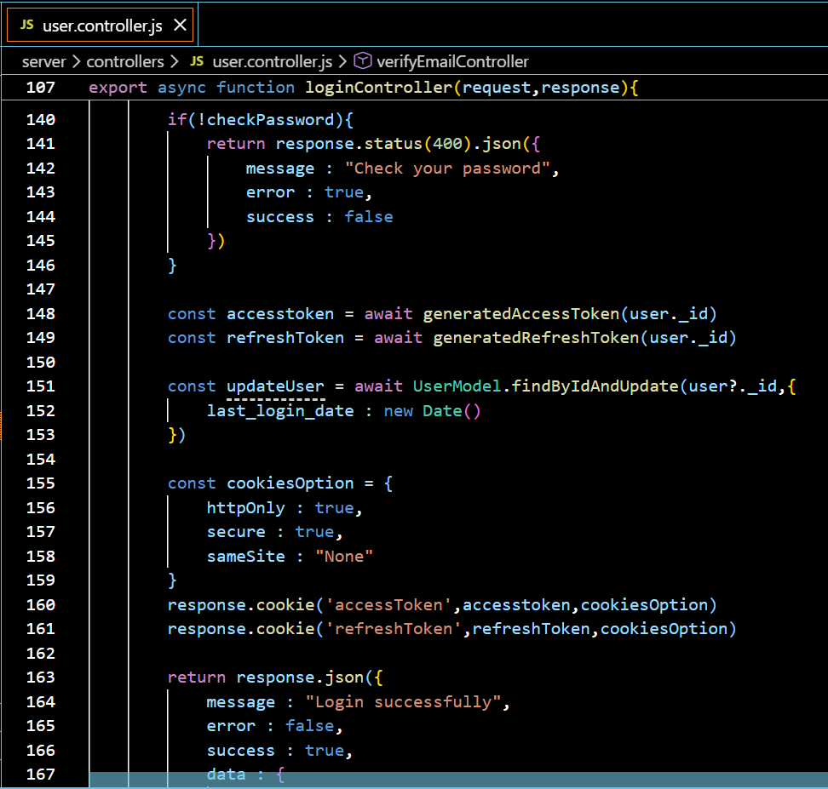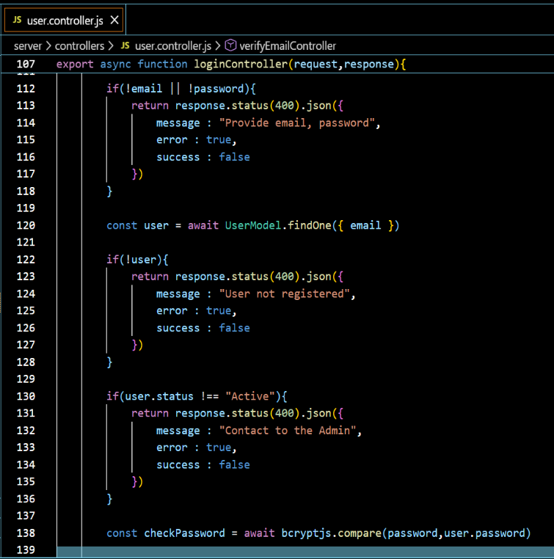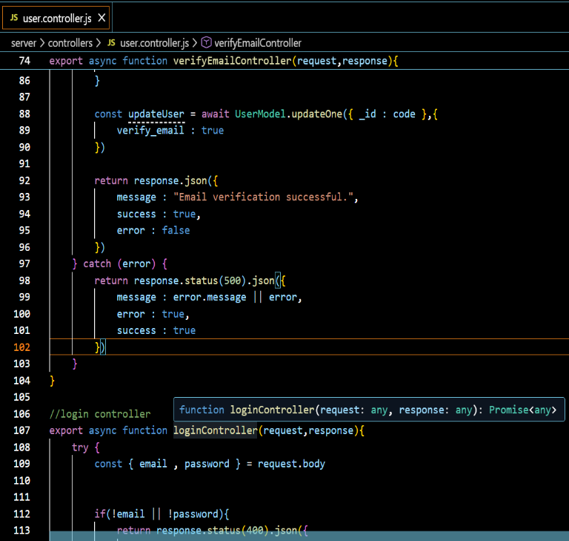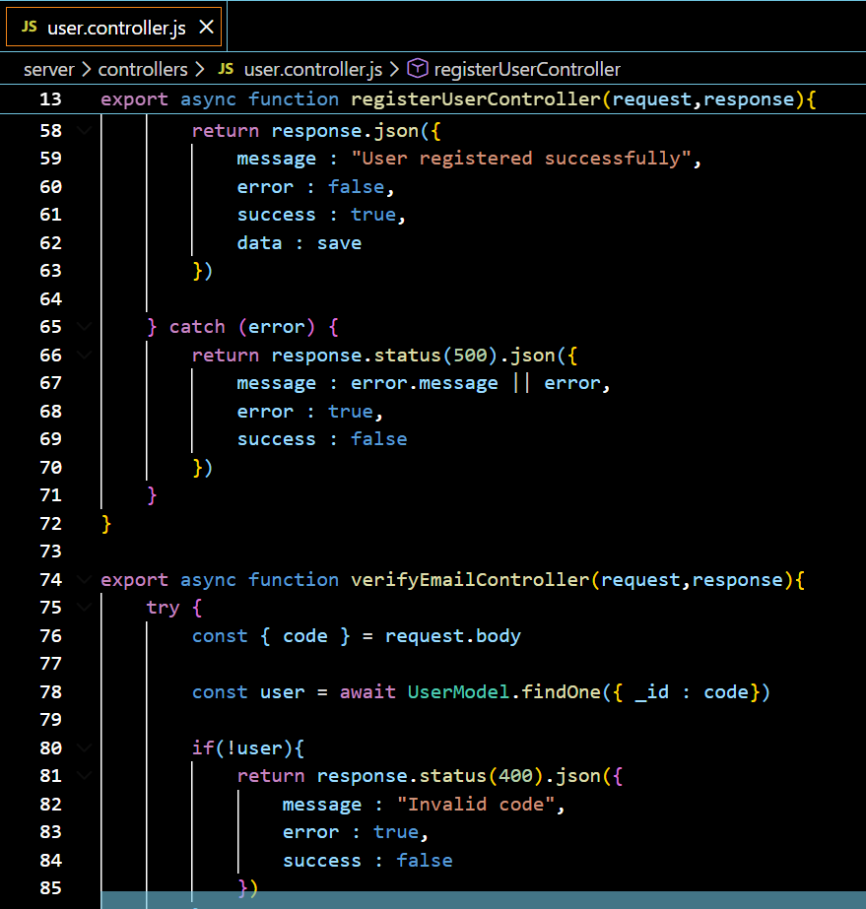

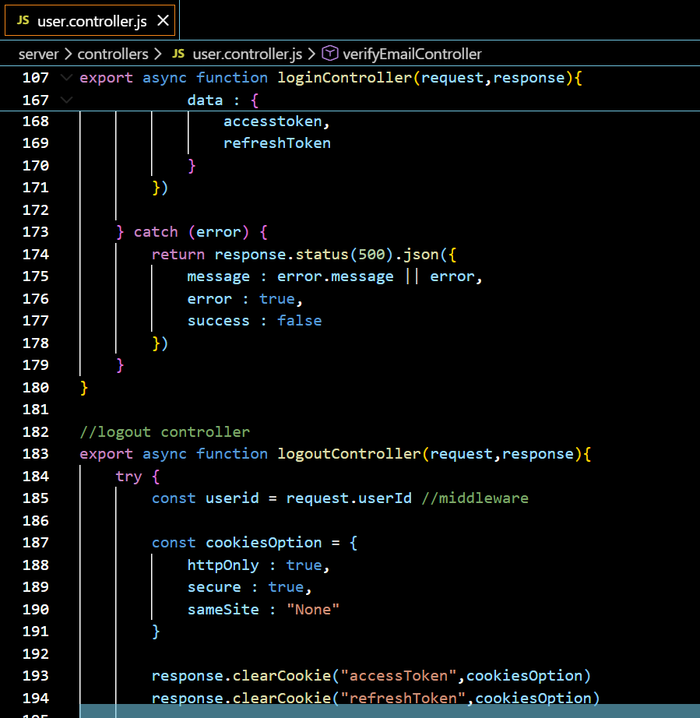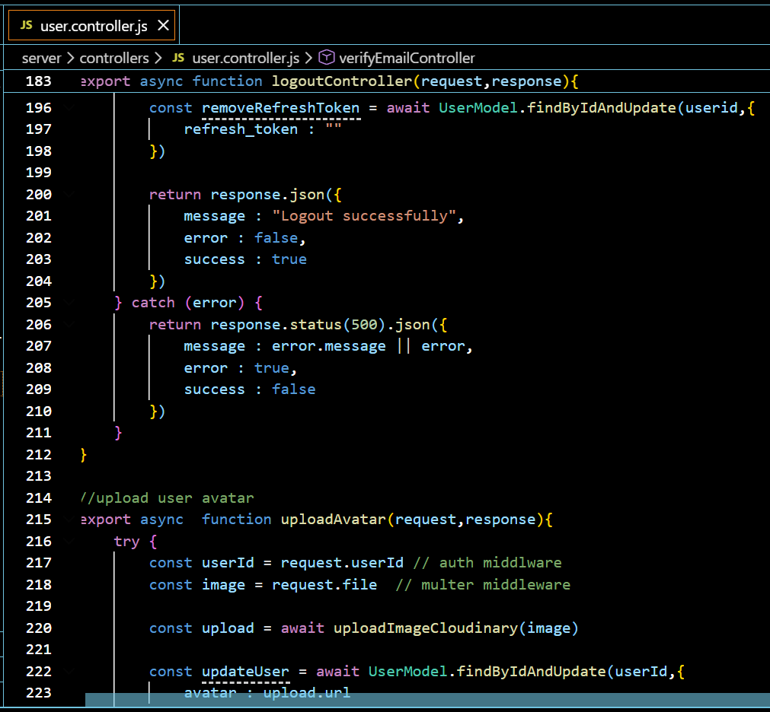

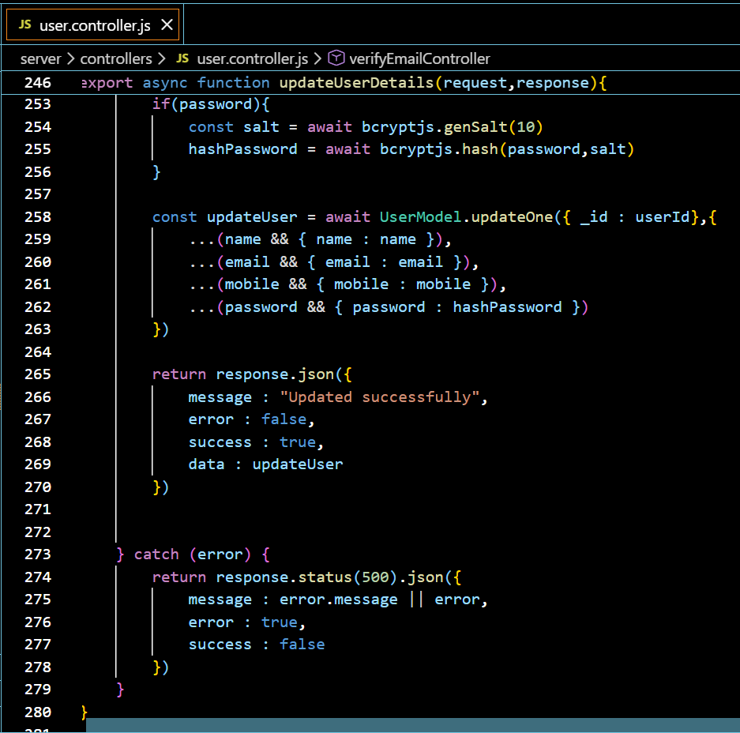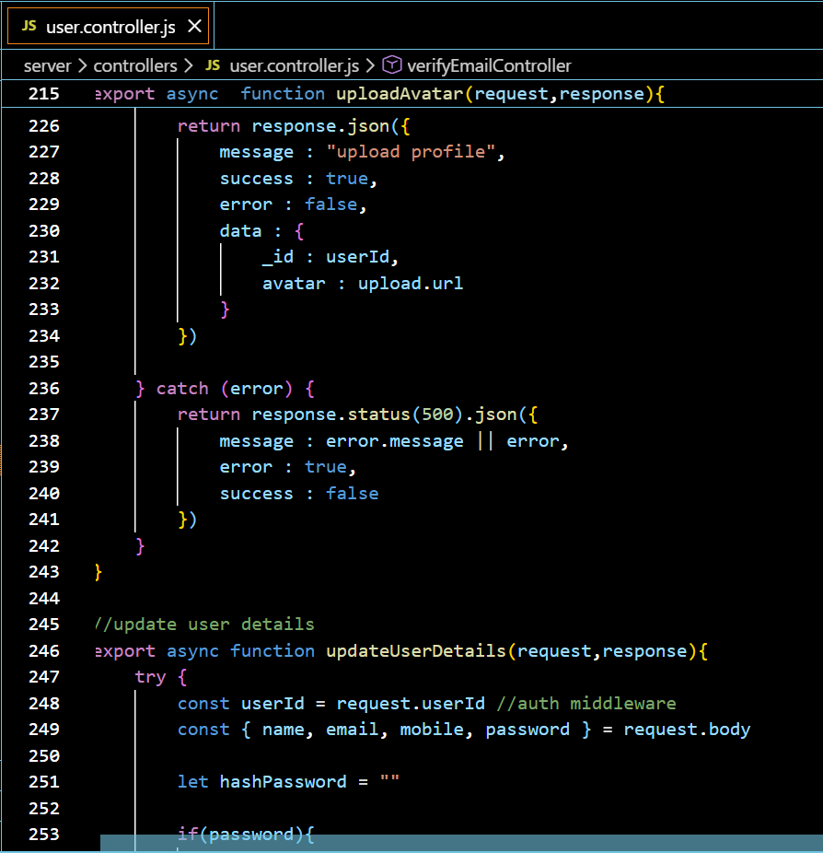

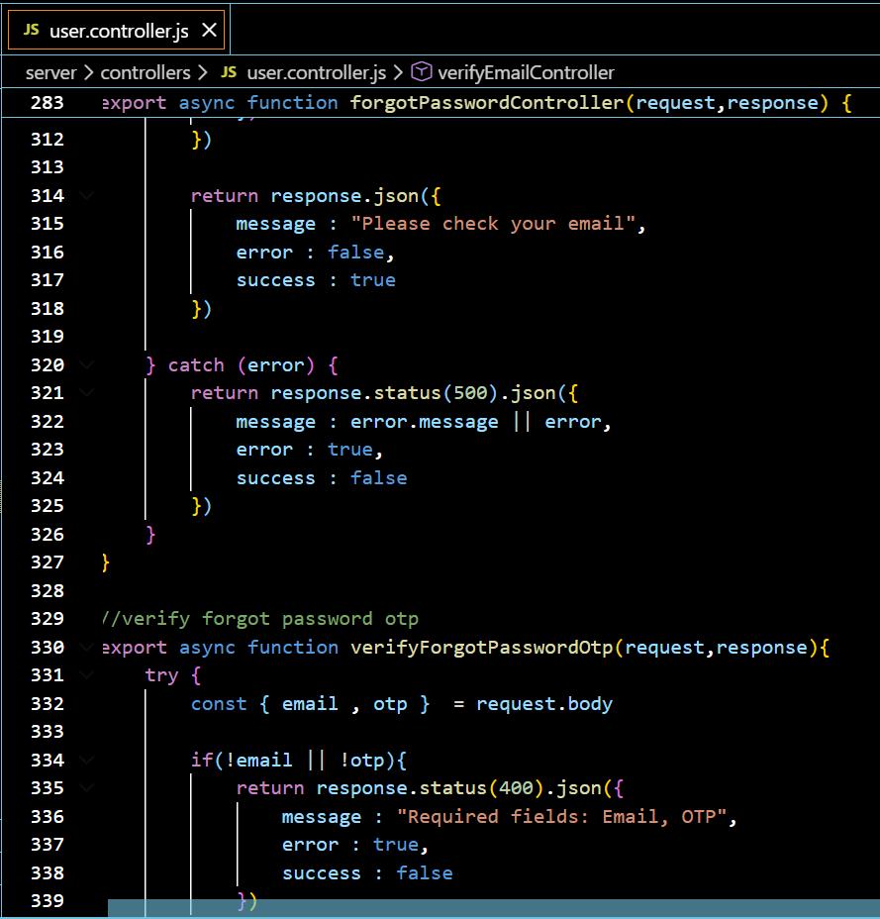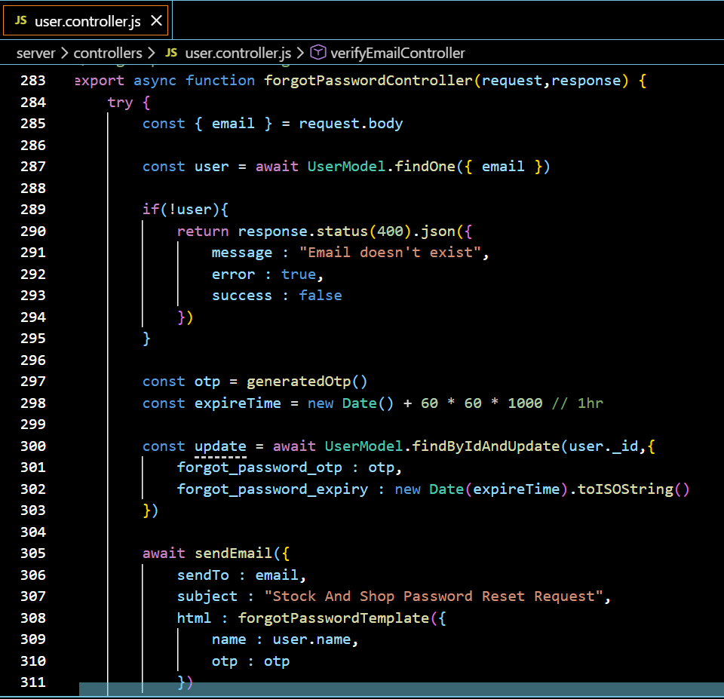

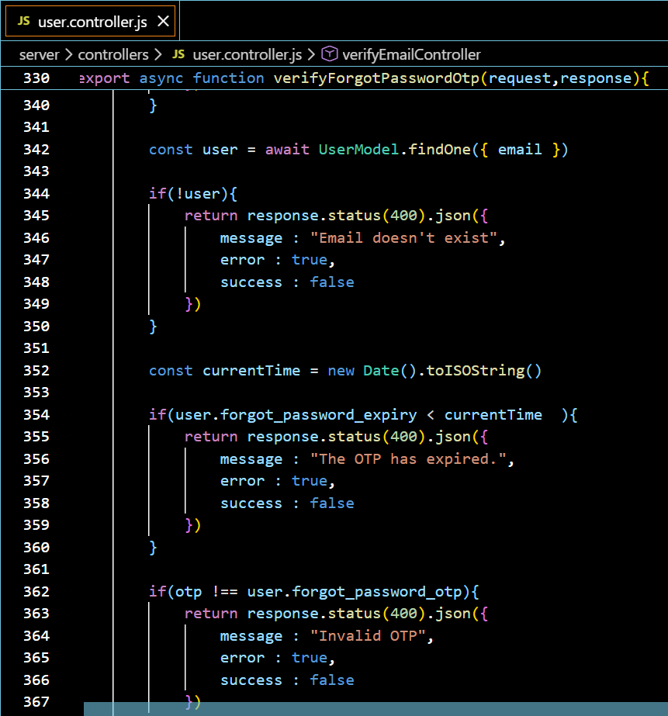

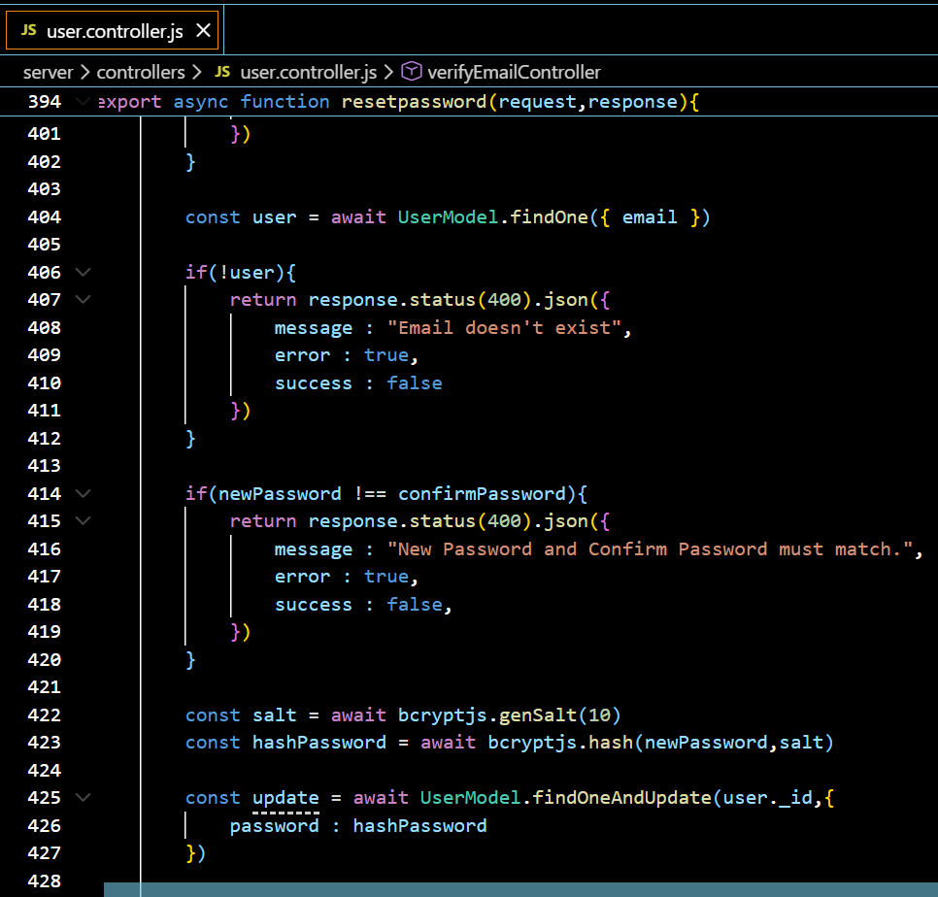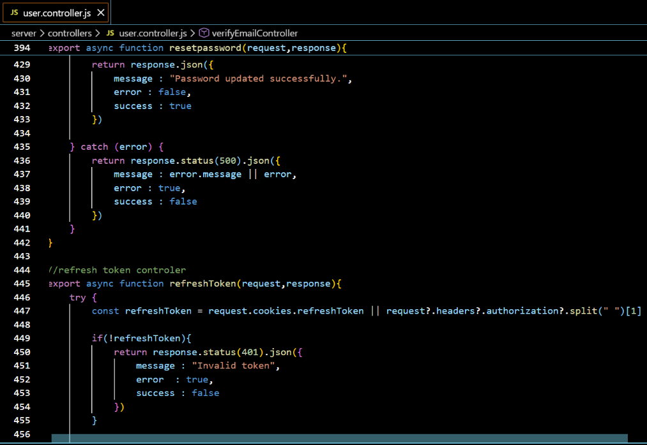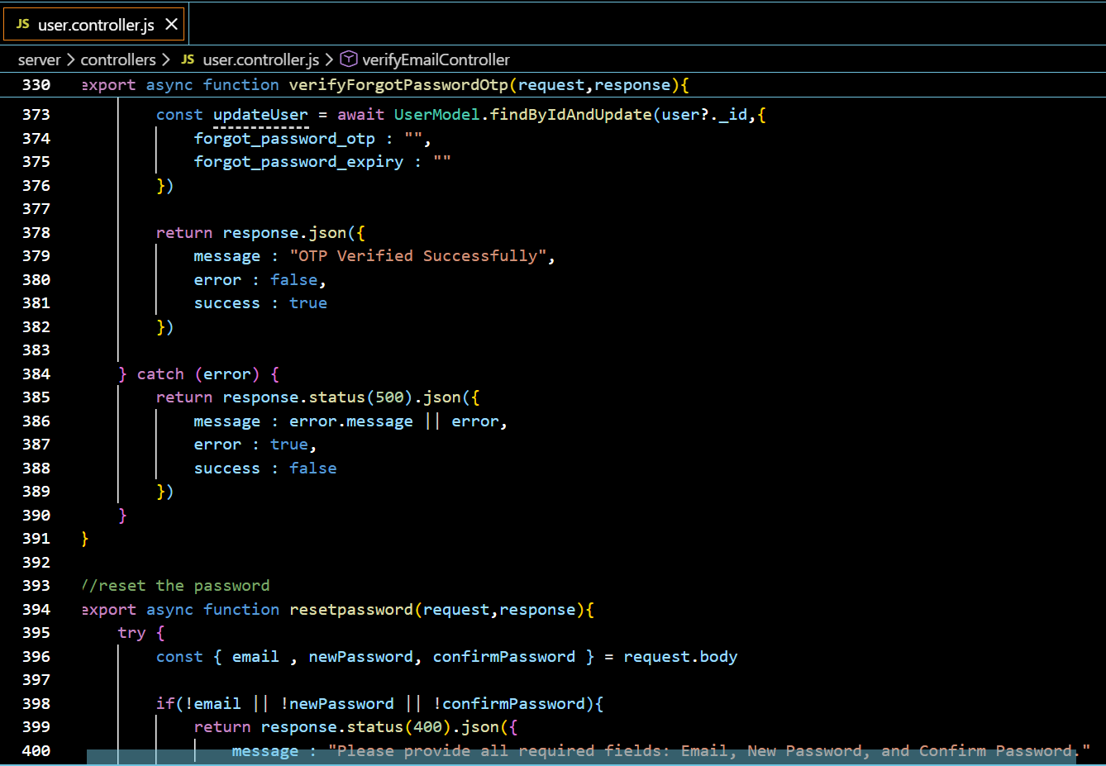

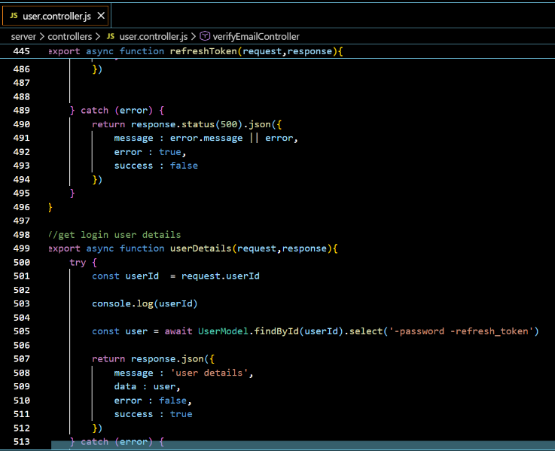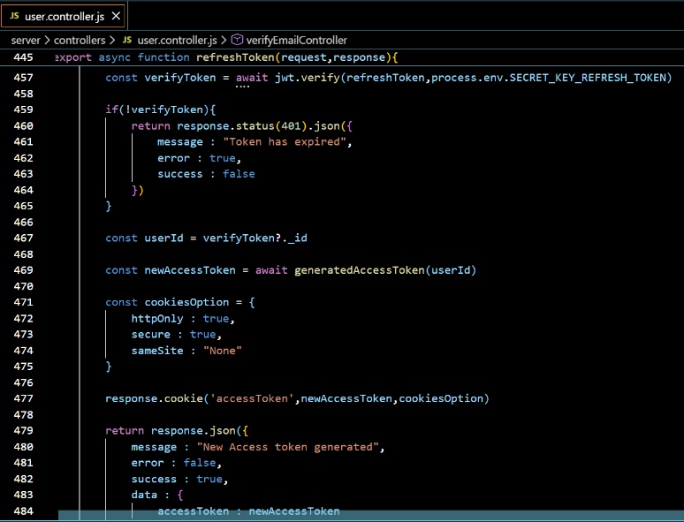

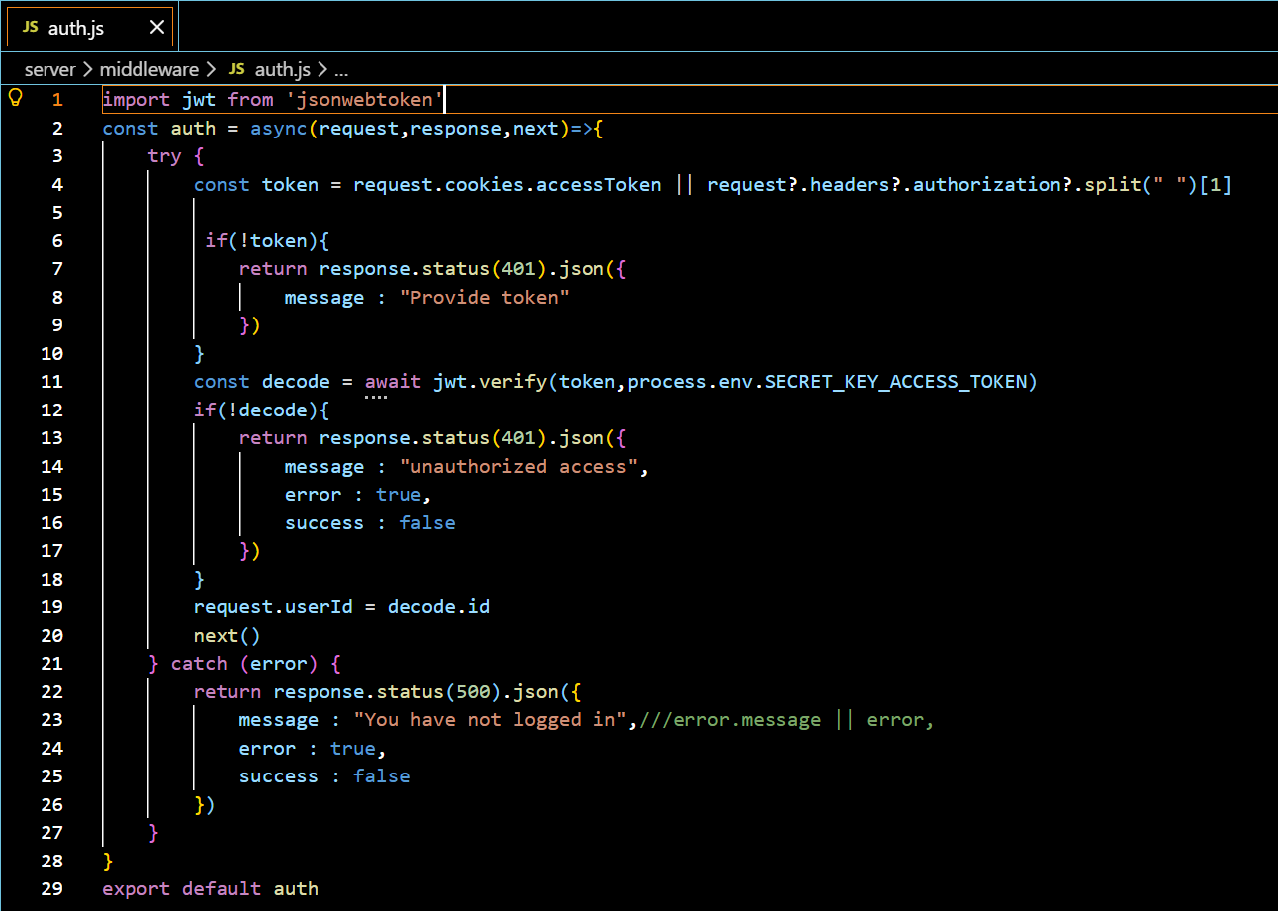

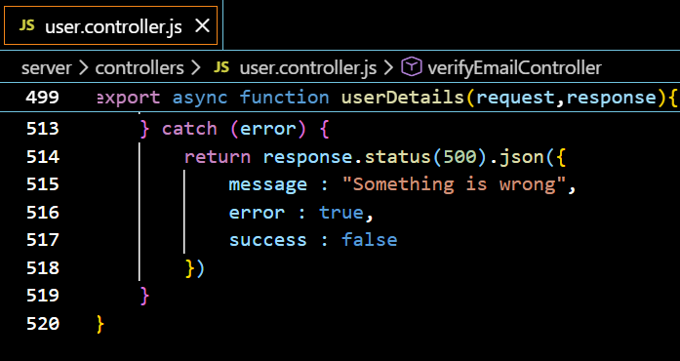

**Figure 4.18: Authentication Controller and JWT Middleware**

**4.4.2 Product & Inventory Code**

* **category.controller.js** – Category CRUD operations
* **subCategory.controller.js** – Sub-category management
* **product.controller.js** – Product upload and stock updates

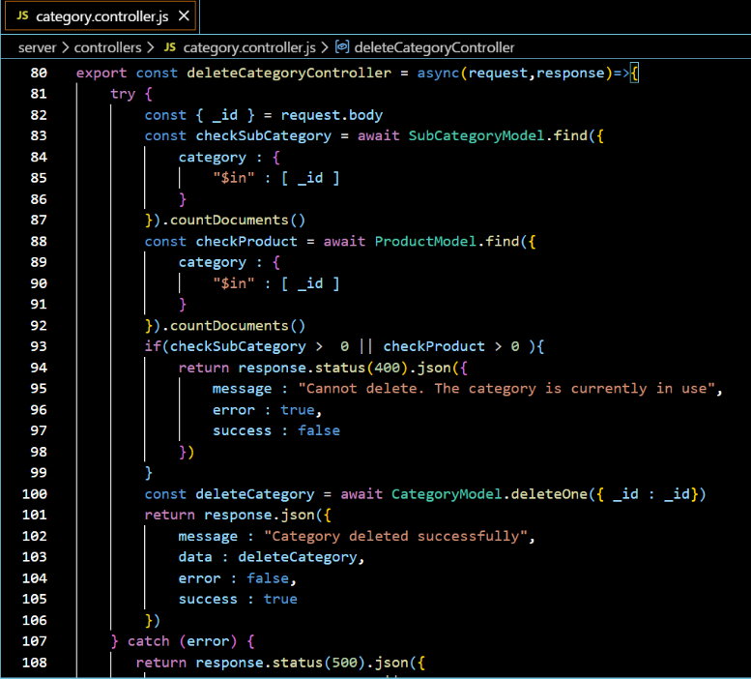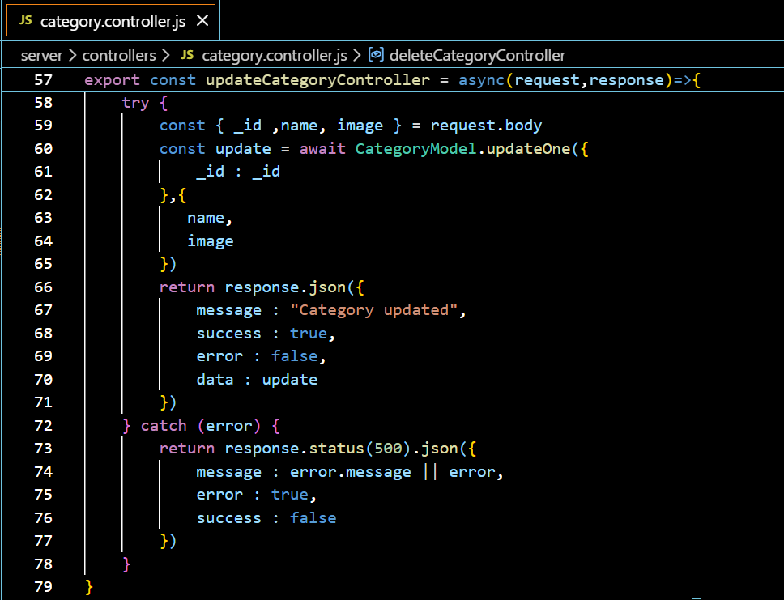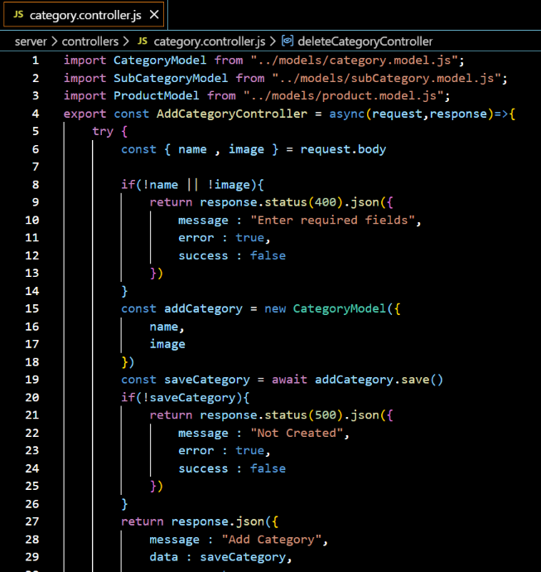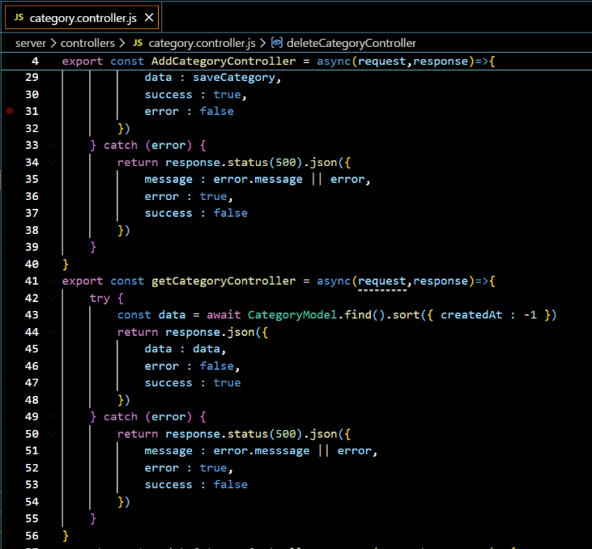

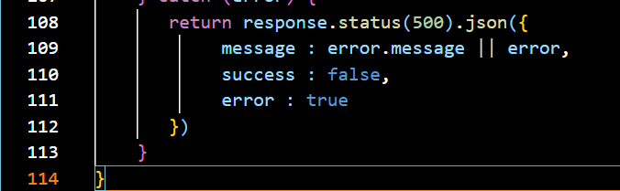

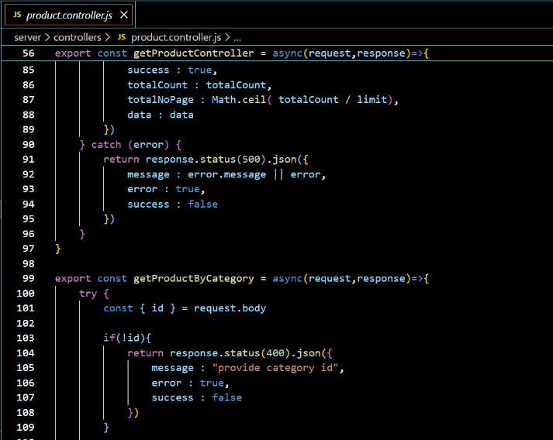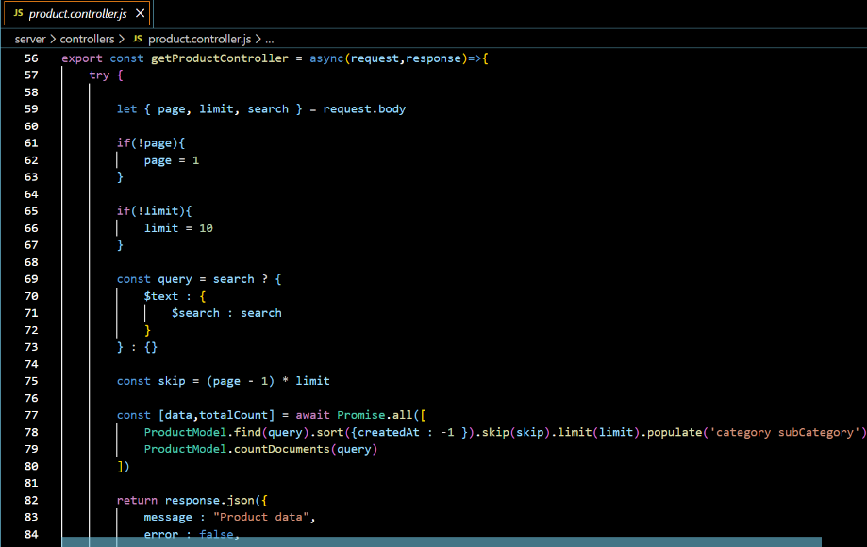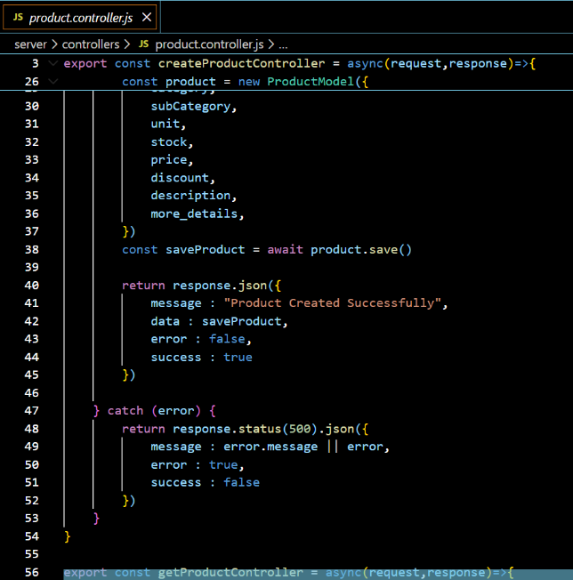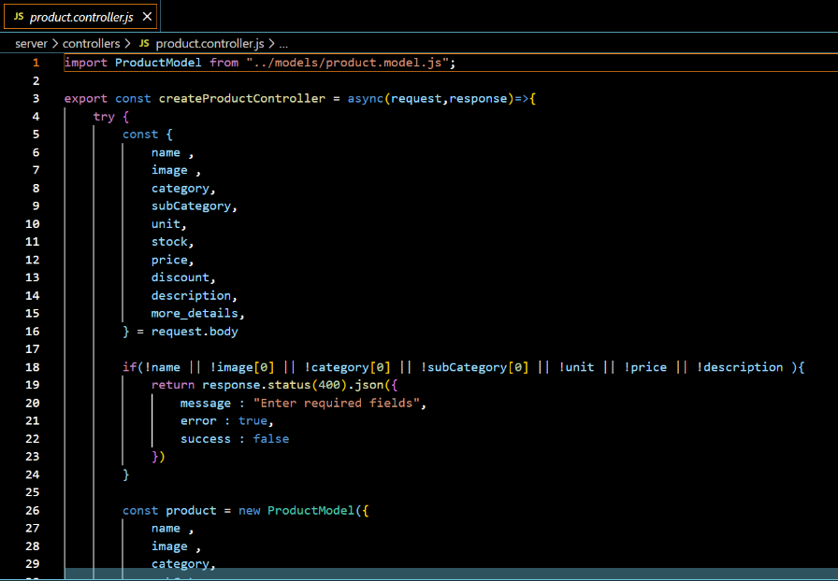

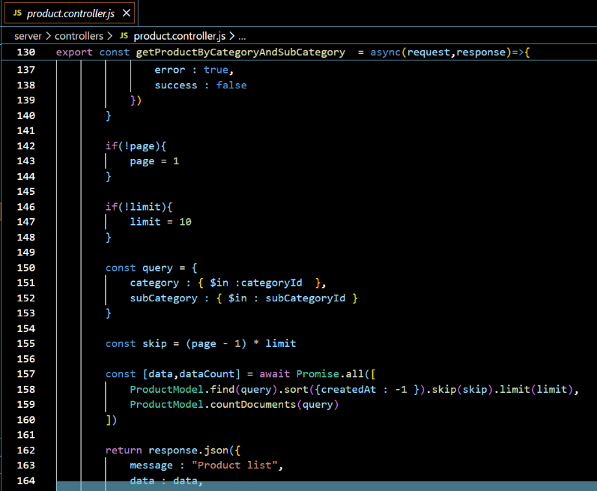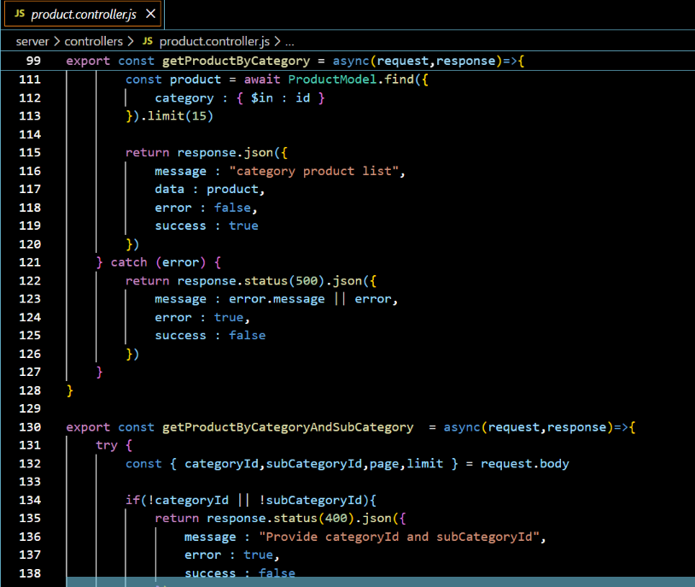

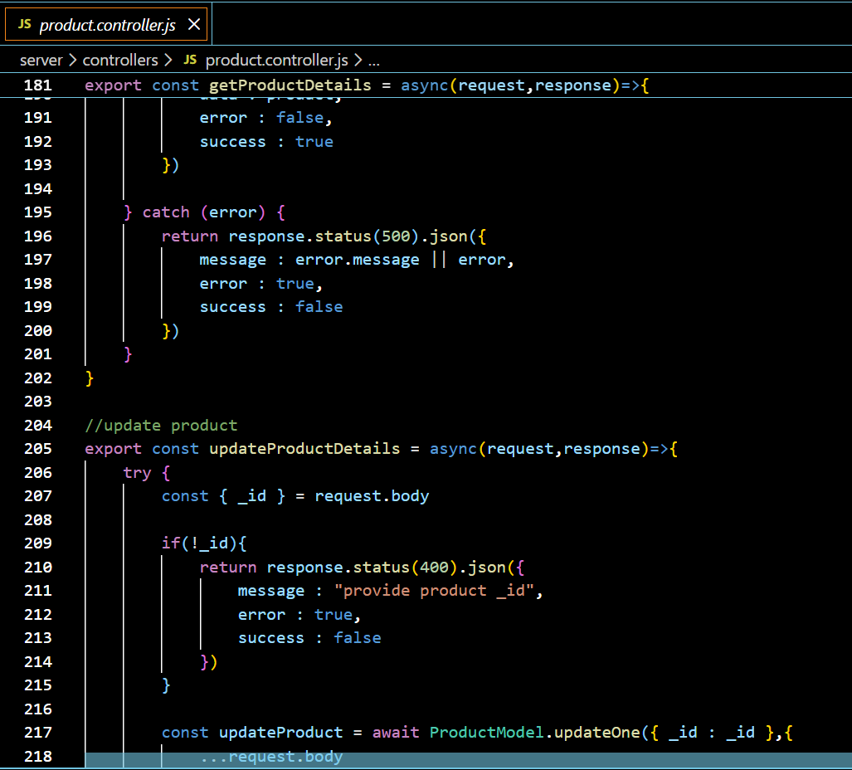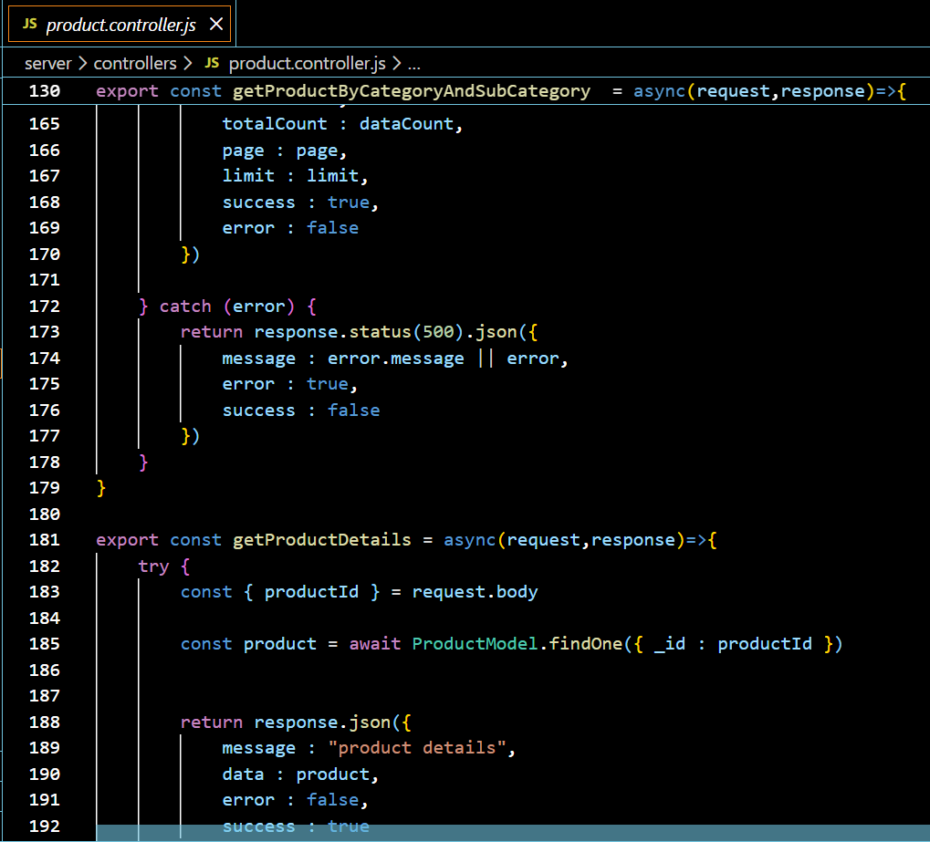

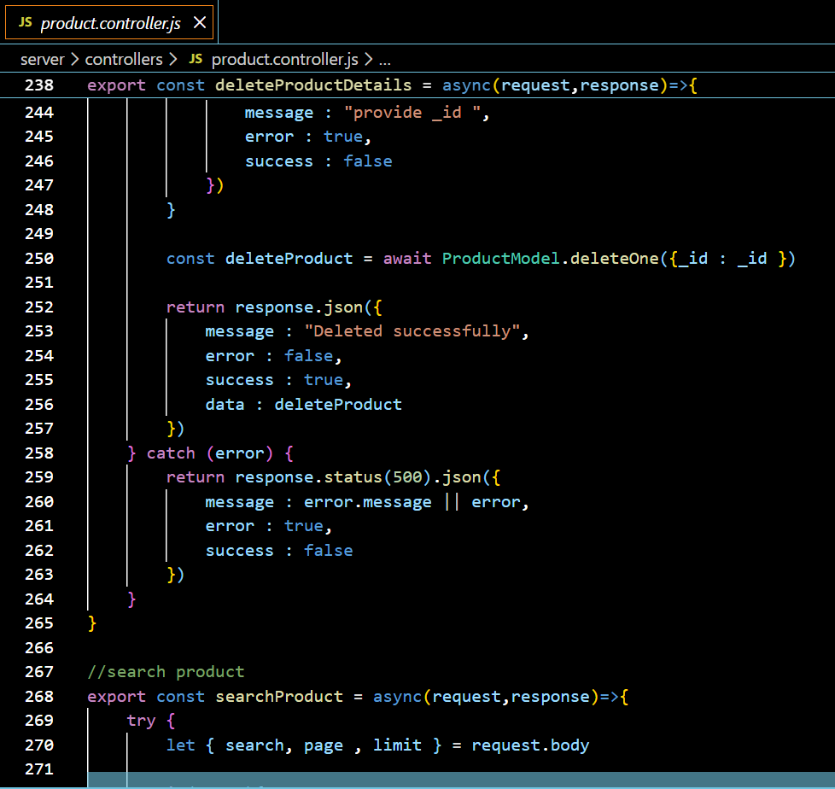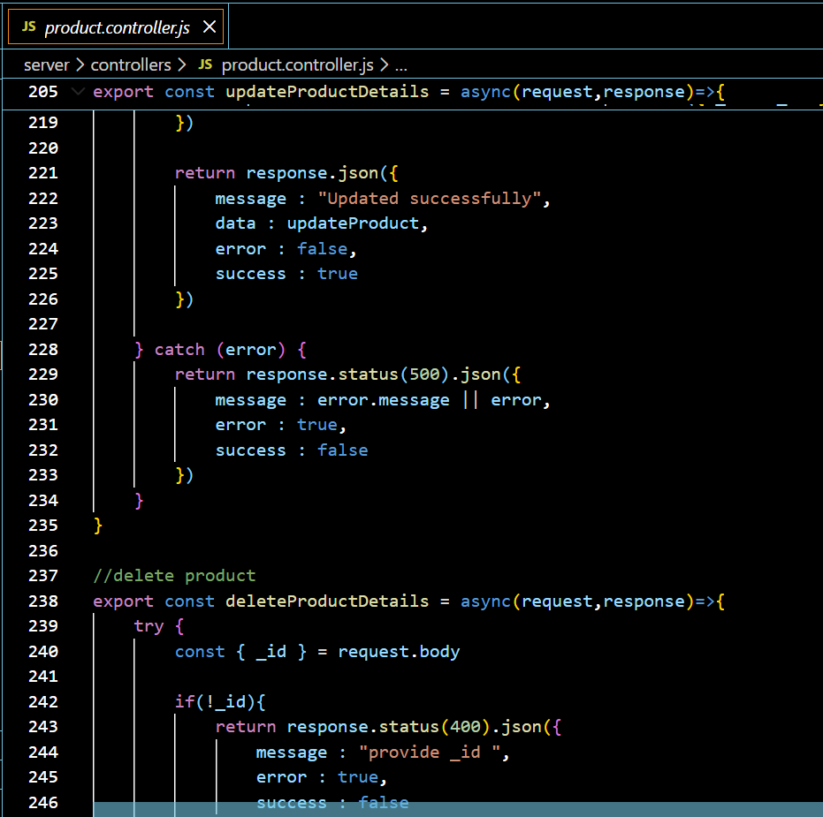

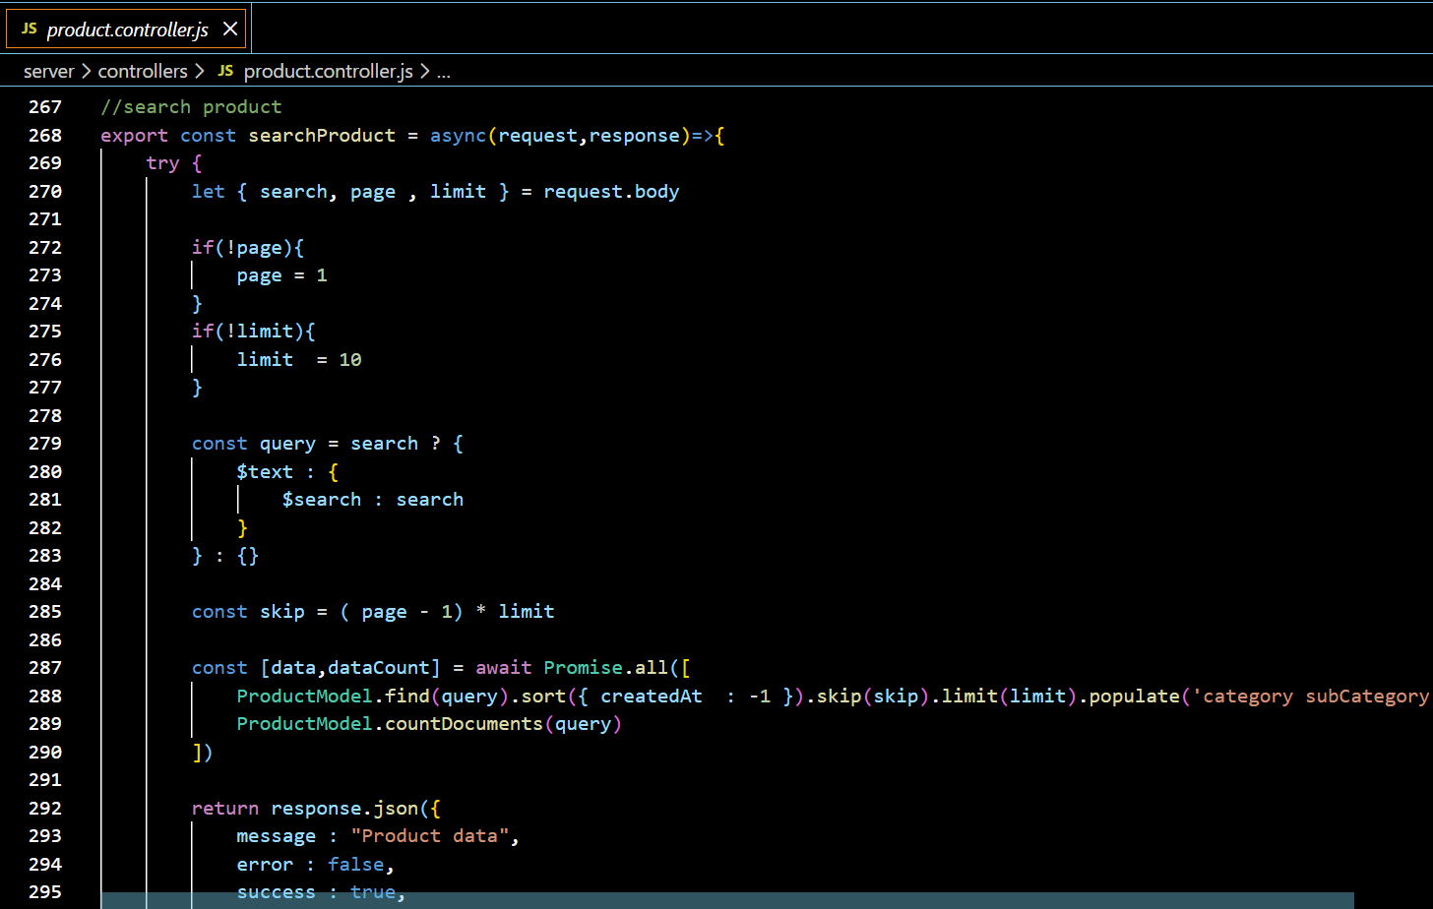

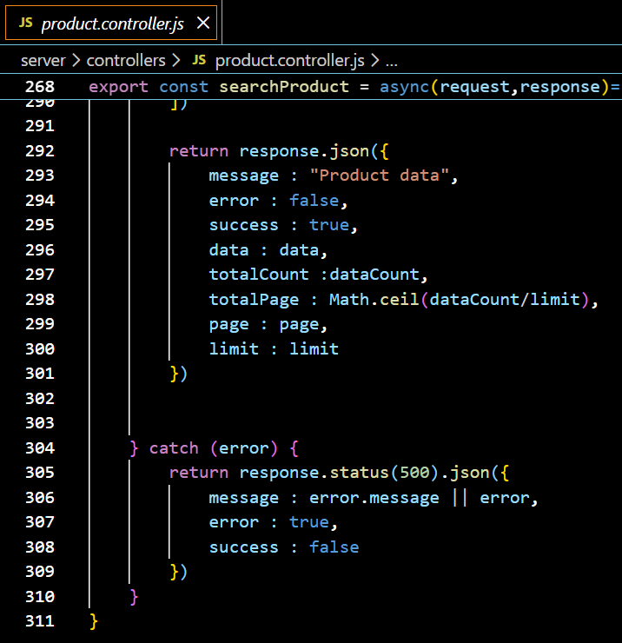

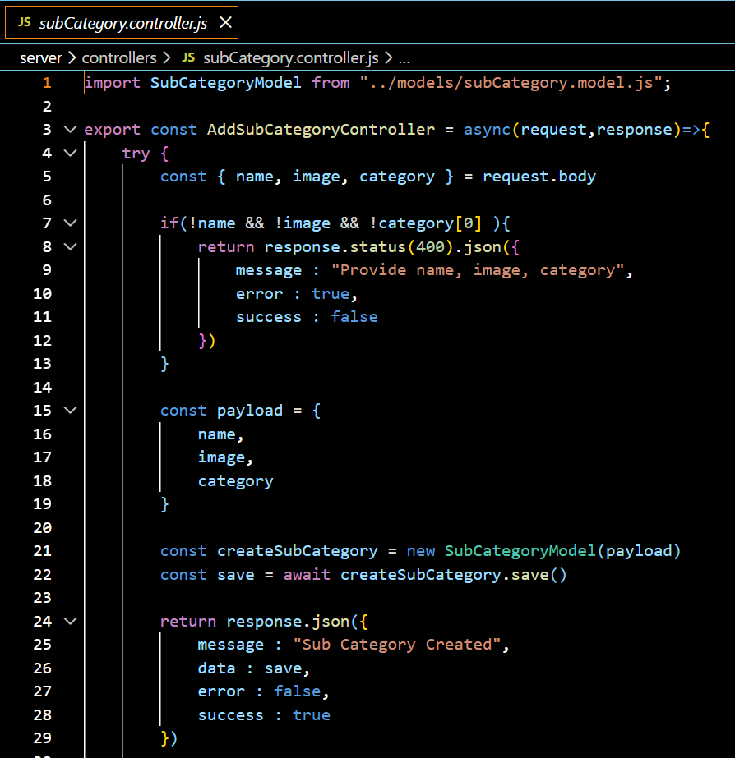

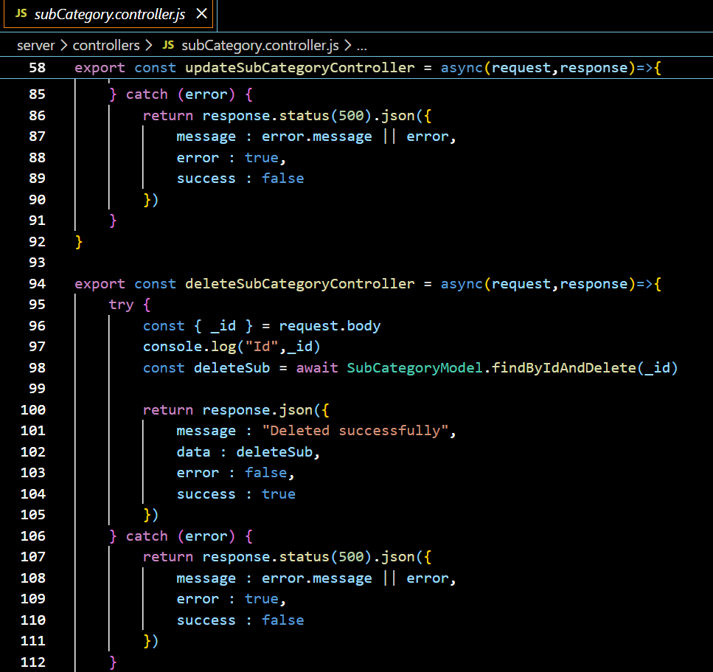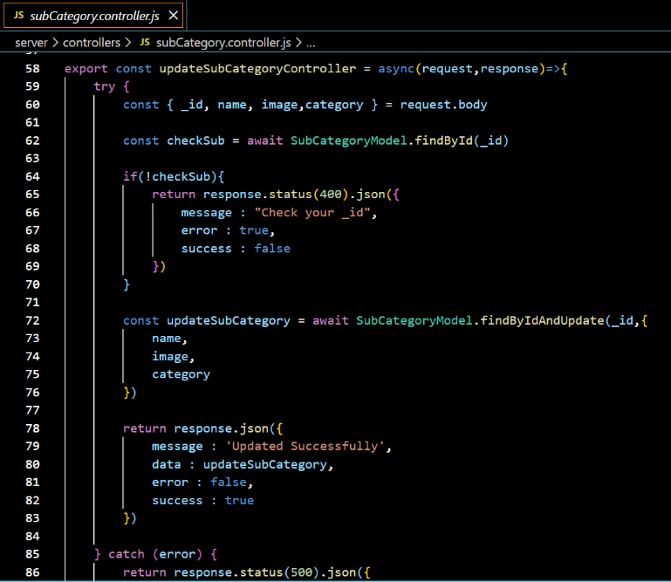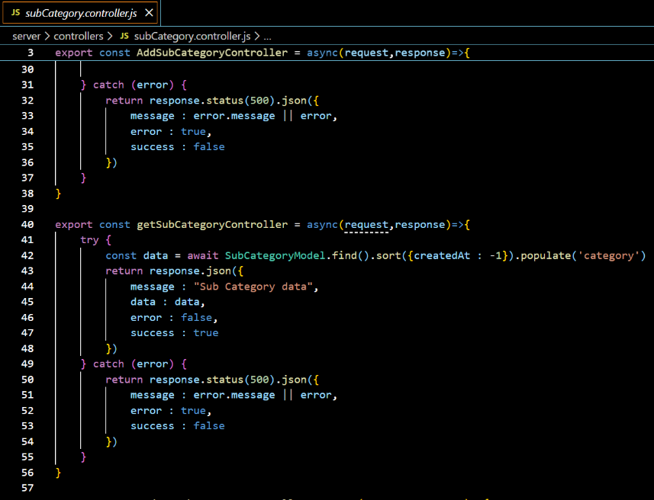

**Figure 4.19: Product and Inventory Controllers**

**4.4.3 Cart & Order Code**

* **cart.controller.js** – Add, update, and remove cart items
* **order.controller.js** – Order creation and order history

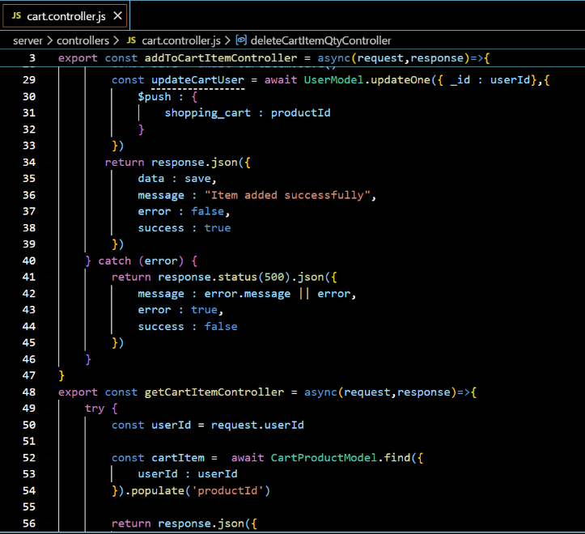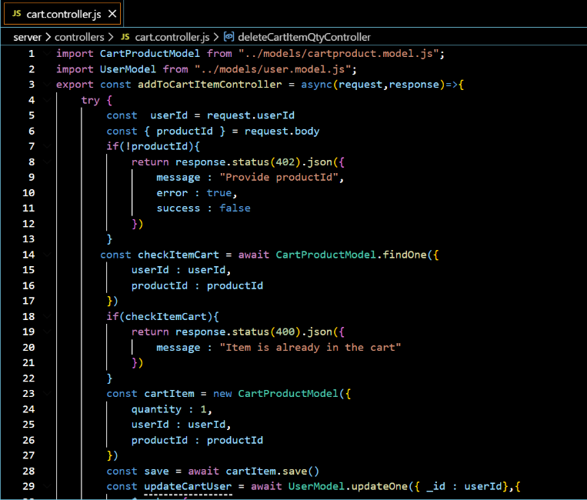

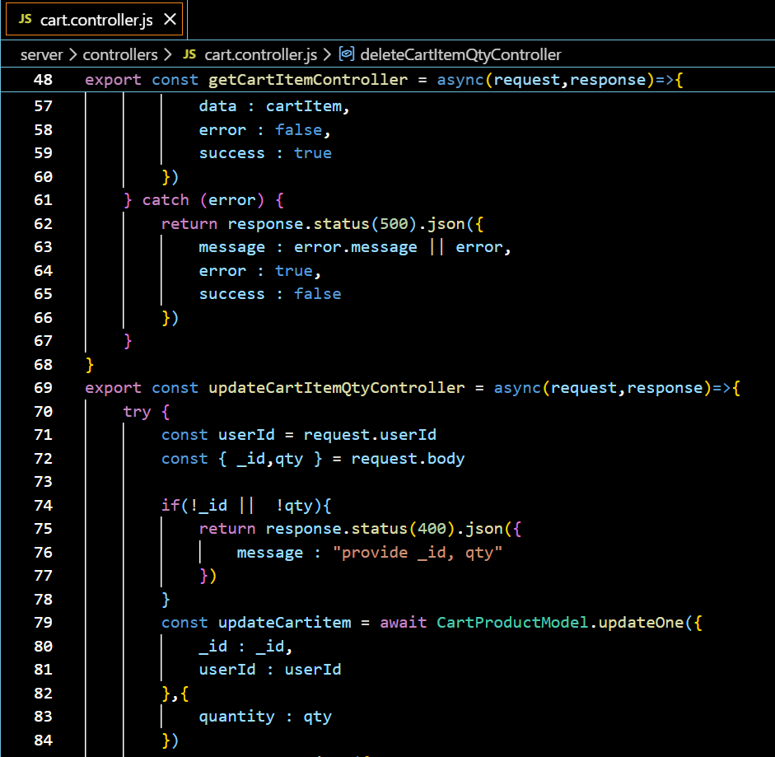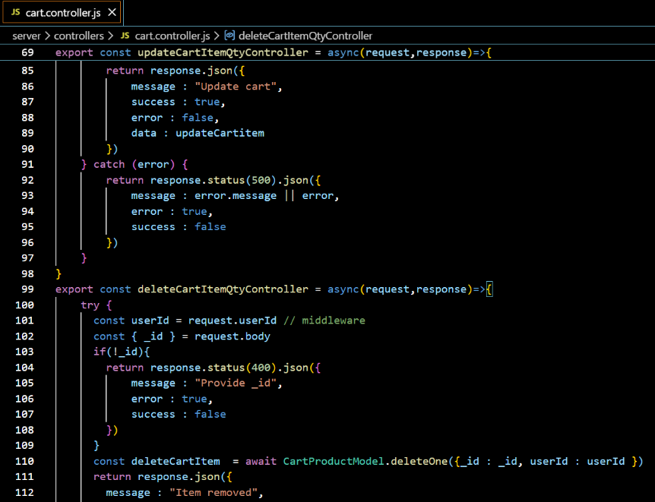

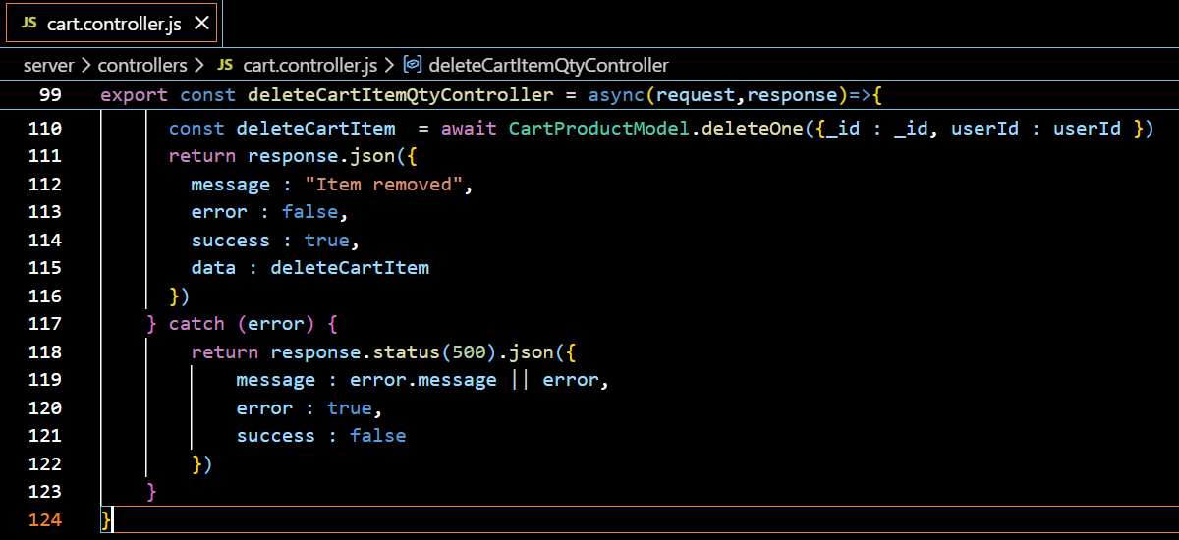

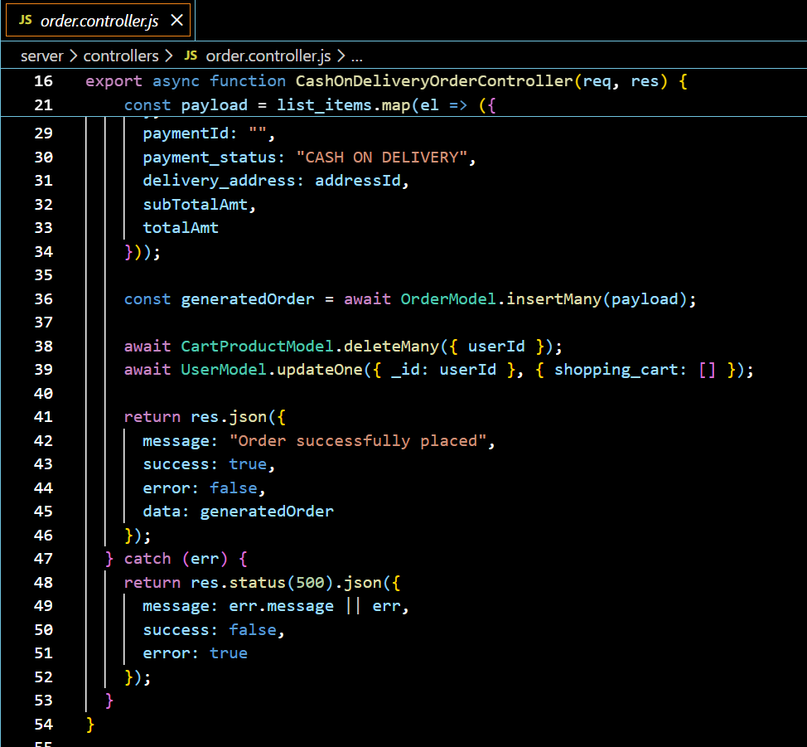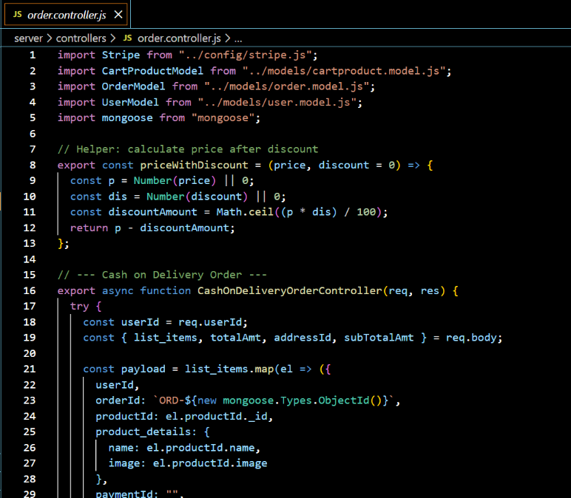

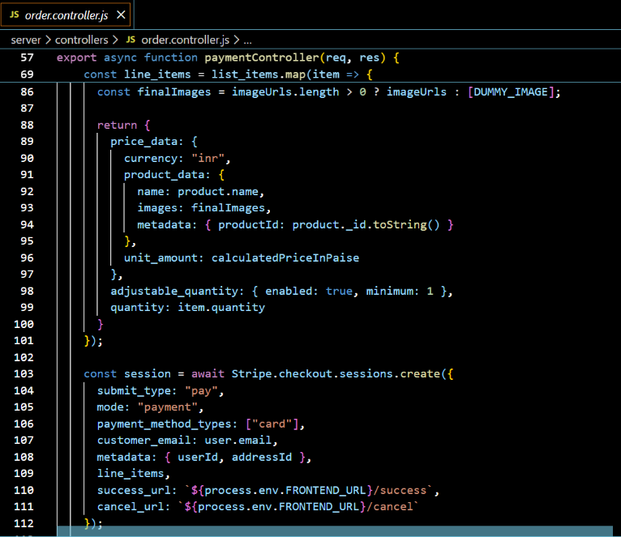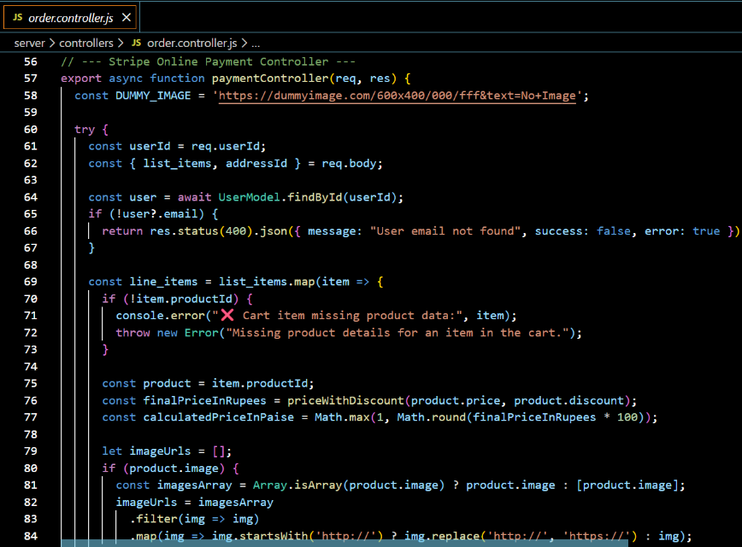

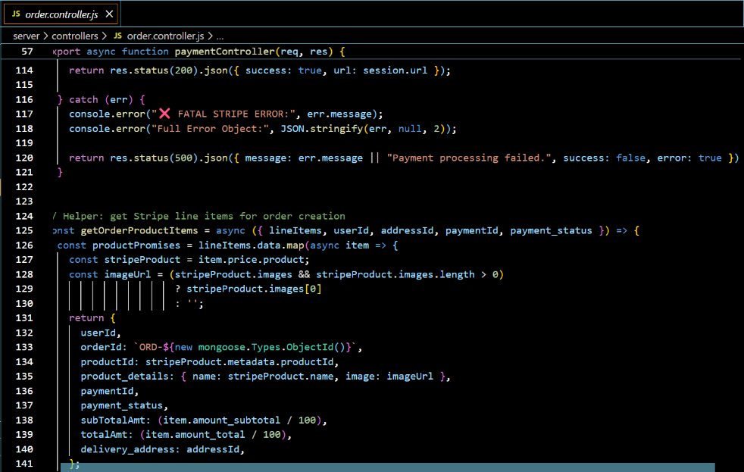

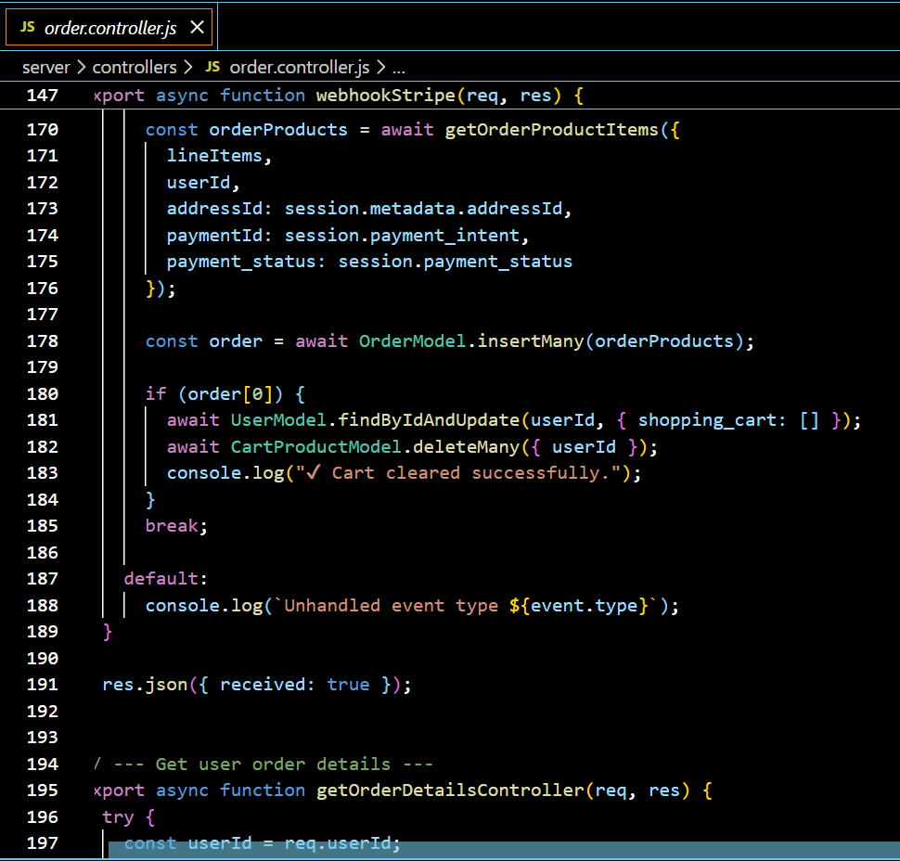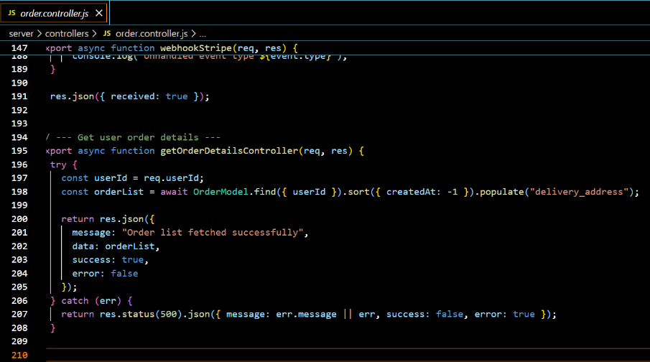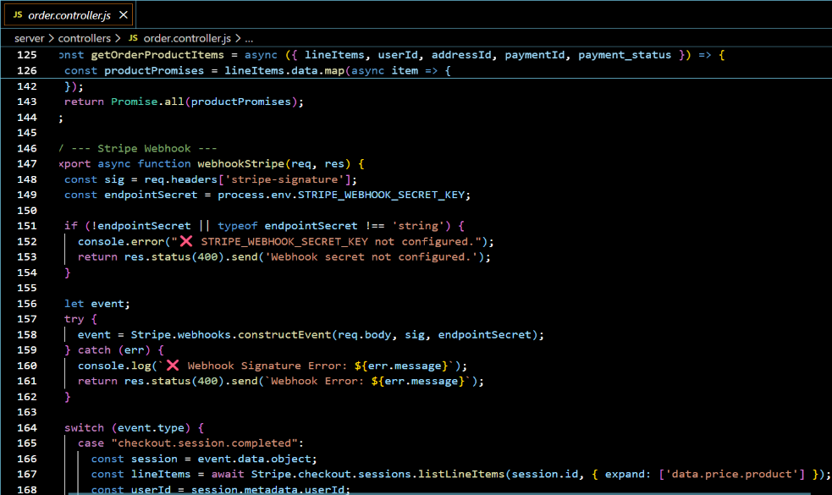

**Figure 4.20: Cart and Order Controllers**

**4.4.4 Payment Gateway Code**

* **stripe.js** – Stripe configuration and checkout session creation
* **Webhook Logic (order.controller.js)** – Payment verification and order confirmation

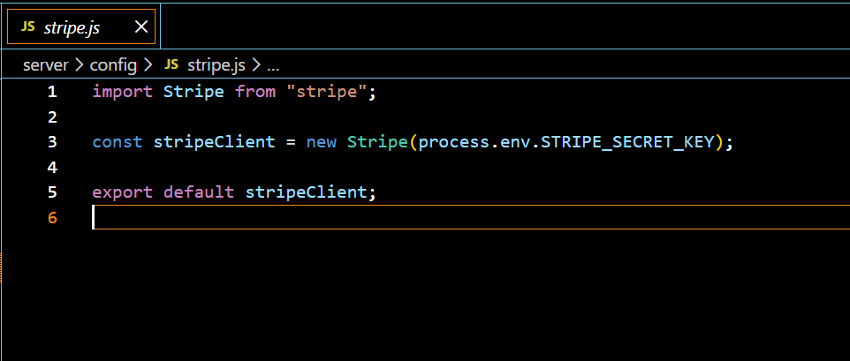

**Figure 4.21: Stripe Checkout**

**4.4.5 Frontend State Management Code**

* **store.js** – Redux store configuration
* **userSlice.js** – User state management
* **cartProduct.js** – Cart state management

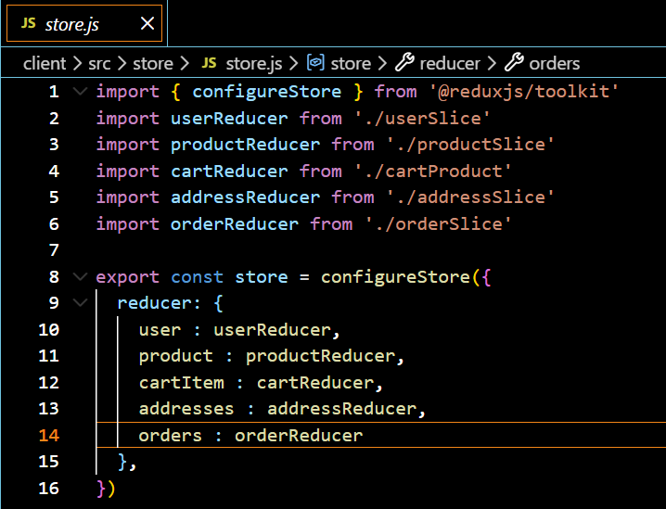

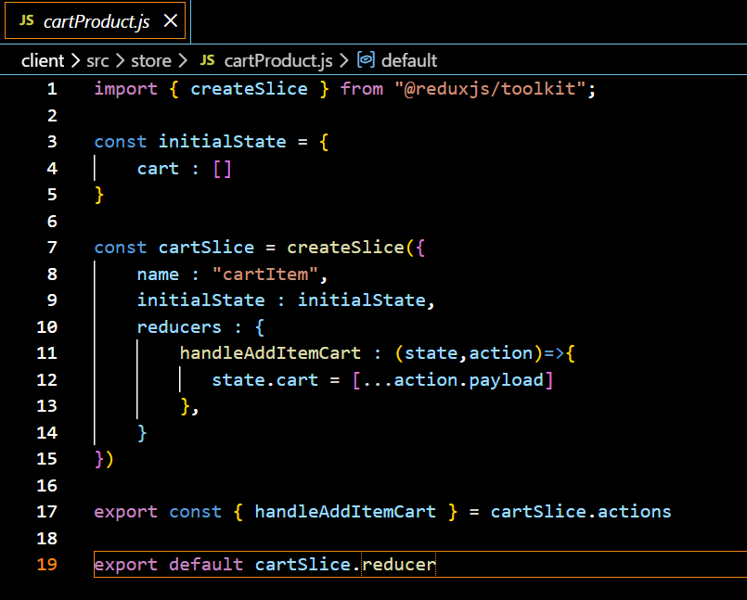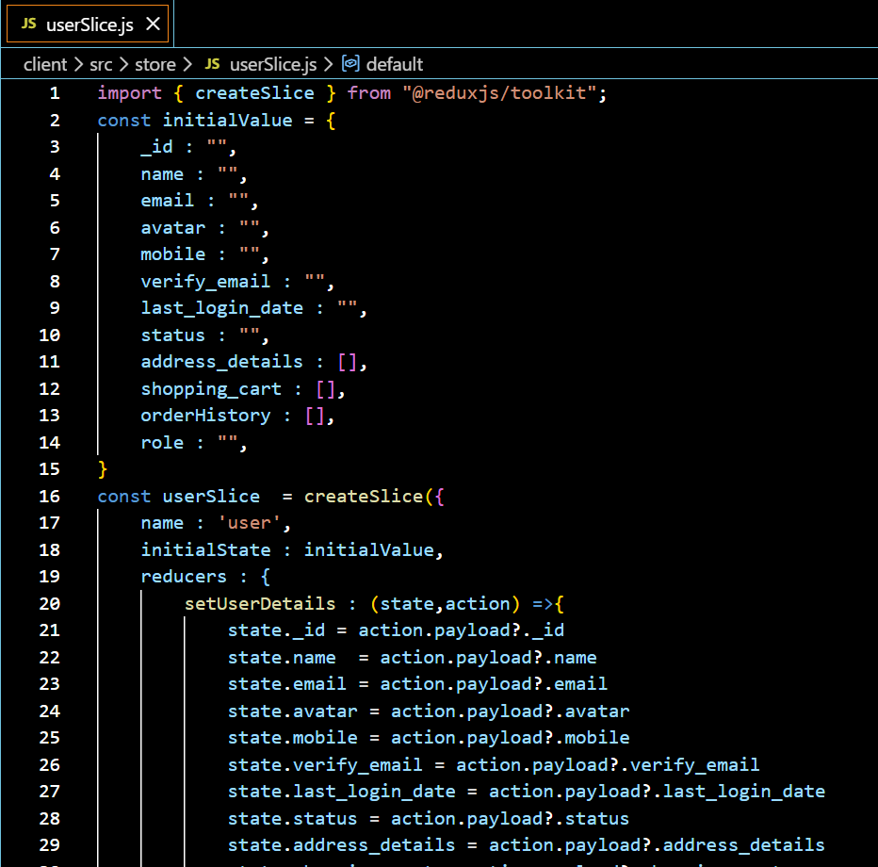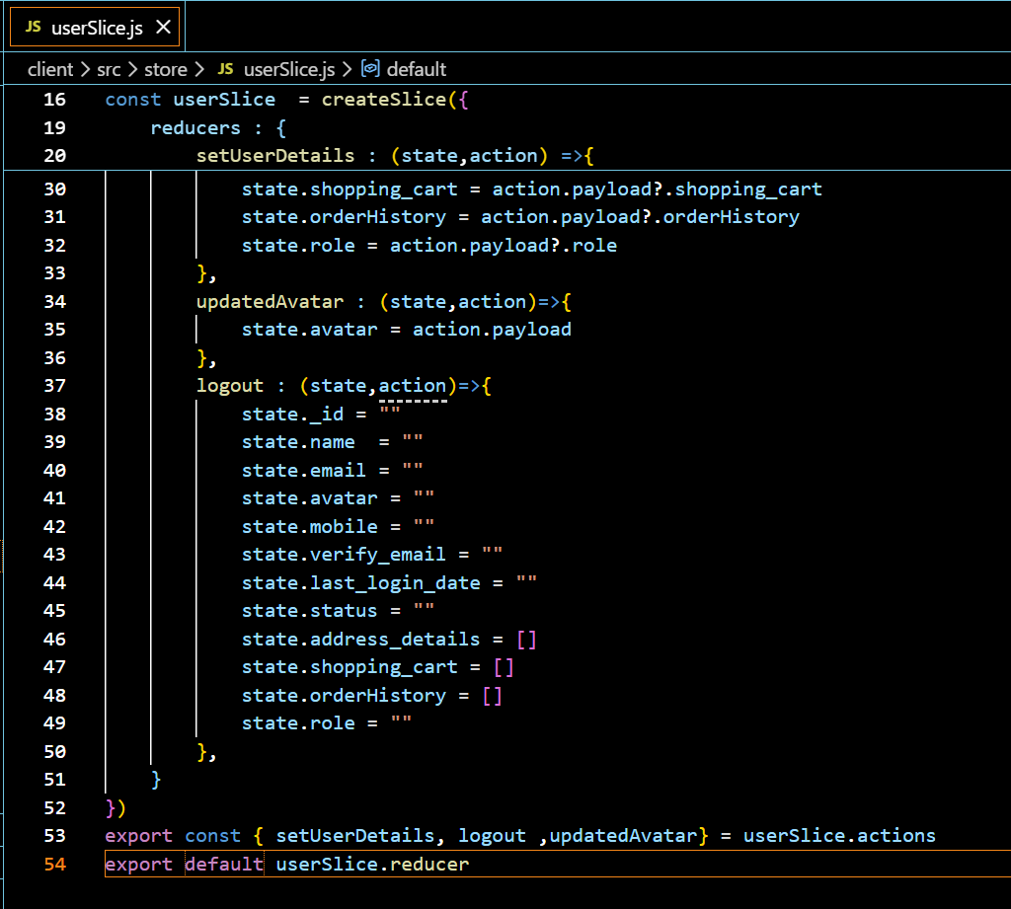

**Figure 4.22: Redux Store and Slice Implementation**

**4.4.6 Utility Code**

* **axios.js** – API request configuration
* **addToCartProduct.js** – Client-side cart handling logic

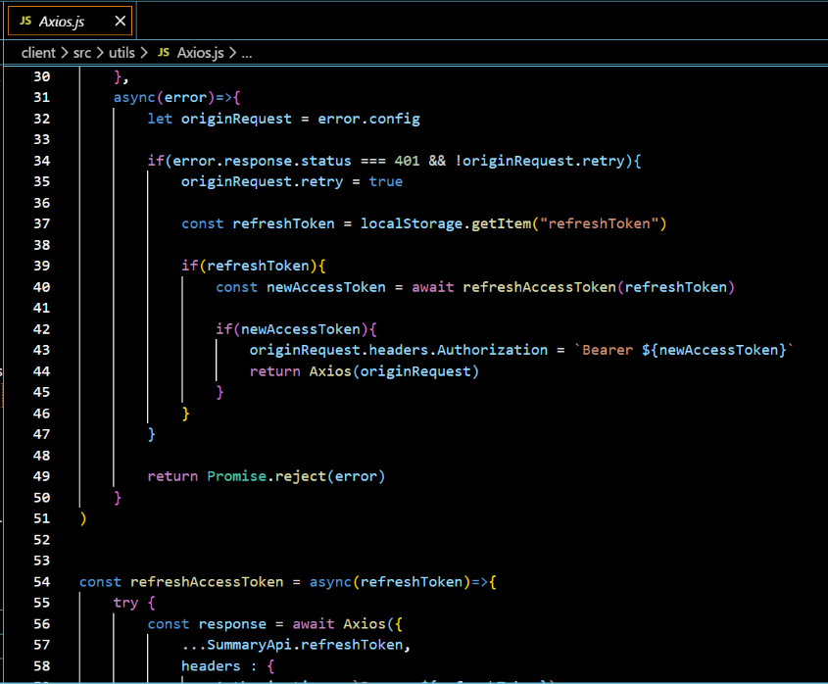

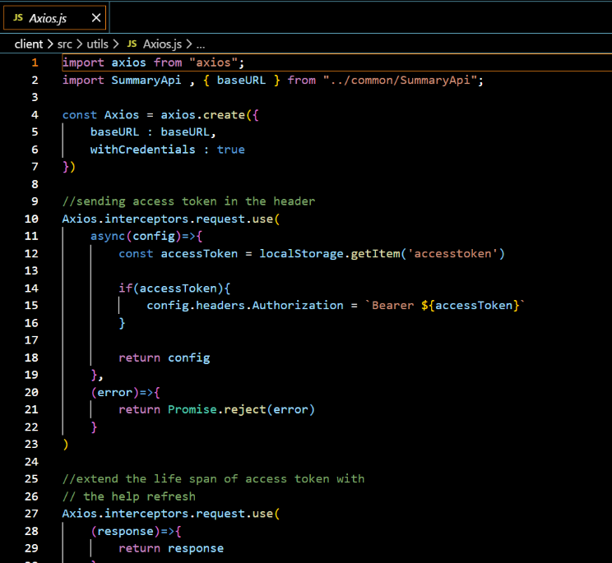

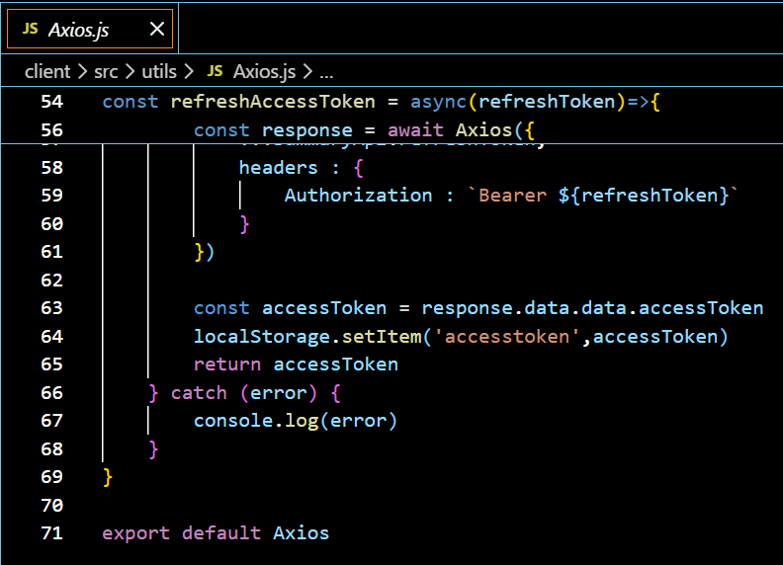

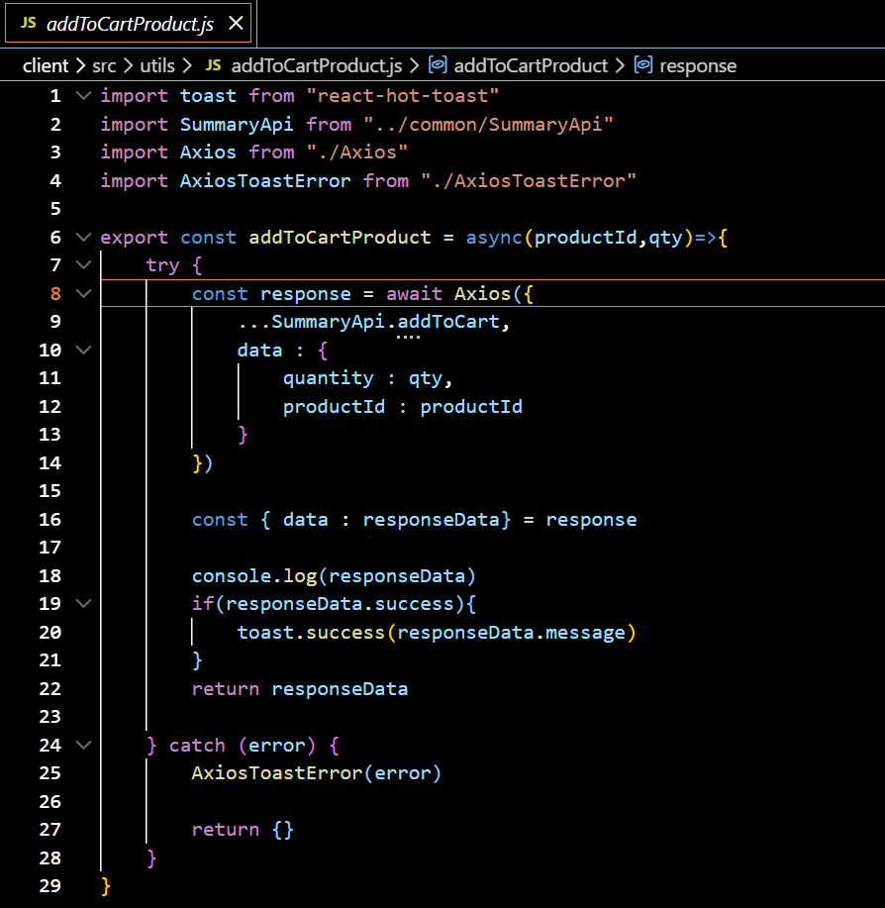

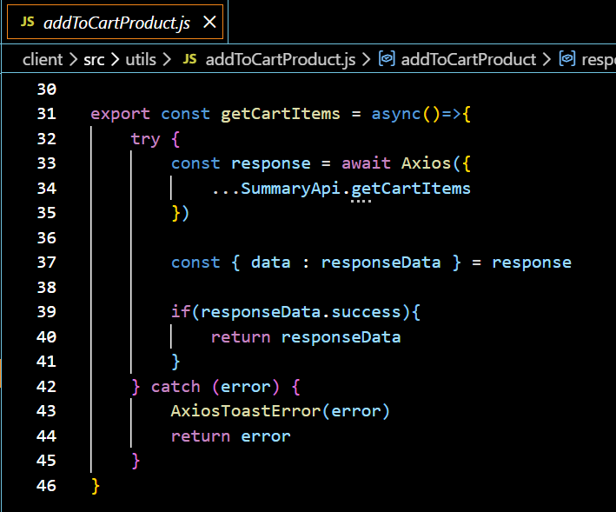

**Figure 4.23: Frontend Utility Functions**

# CHAPTER – 5

# TESTING AND MAINTENANCE

This chapter describes the testing strategies adopted for the “**Stock & Shop**” E-Commerce System, the test cases executed to verify system functionality, system evaluation, future enhancements, cost–benefit analysis, and a brief user/operational manual.

**Testing Methodology Adopted**

The **Black Box Testing** methodology was primarily used to test the system. This approach focuses on validating the functionality of the application without considering the internal code structure. Each module was tested based on expected inputs and outputs to ensure correctness, reliability, and usability.

In addition, integration testing was carried out to ensure seamless communication between frontend, backend, database, and third-party services such as Stripe.

**Test Cases and Expected Results**

|  |  |  |  |  |
| --- | --- | --- | --- | --- |
| **Test Case ID** | **Module** | **Input** | **Expected Result** | **Status** |
| TC-01 | User Registration | Valid user details | User successfully registered | Pass |
| TC-02 | User Login | Valid credentials | Login successful with JWT token | Pass |
| TC-03 | Forgot Password | Registered email | OTP sent to email | Pass |
| TC-04 | Category Creation | Valid category details | Category added successfully | Pass |
| TC-05 | Product Upload | Valid product data | Product stored in database | Pass |
| TC-06 | Add to Cart | Selected product | Product added to cart | Pass |
| TC-07 | Checkout | Valid cart items | Redirected to Stripe Checkout | Pass |
| TC-08 | Payment Success | Valid card details | Order created and cart cleared | Pass |

|  |  |  |  |  |
| --- | --- | --- | --- | --- |
|  |  |  |  |  |
|  |  |  |  |  |
|  |  |  |  |  |
|  |  |  |  |  |
|  |  |  |  |  |
|  |  |  |  |  |
|  |  |  |  |  |
|  |  |  |  |  |

**System Evaluation**

The “Stock & Shop” system was evaluated based on performance, security, scalability, and usability.

* **Performance:** The MERN stack ensures fast API responses and dynamic UI rendering.
* **Security:** JWT authentication, bcrypt password hashing, and Stripe’s PCI-compliant payment processing provide strong security.
* **Scalability:** MongoDB and modular backend architecture allow the system to scale with increased users and products.
* **Usability:** The user-friendly interface makes navigation simple for both Admin and Customers.

Overall, the system meets all the defined objectives efficiently.

**Future Scope**

The system can be further enhanced with the following features:

* Deployment on cloud platforms (AWS / Vercel)
* Mobile application integration
* Advanced analytics for admin dashboard
* Product recommendations using AI
* Multiple payment gateway support
* Real-time order tracking

**Cost and Benefit Analysis**

**Cost Factors**

* Development time and effort
* Internet and hardware resources
* Stripe transaction fees (only on successful payments)

**Benefits**

* 24/7 online availability
* Reduced manual inventory errors
* Secure digital payments
* Improved customer experience
* Efficient order management

The benefits significantly outweigh the costs, making the system economically viable.

**User / Operational Manual**

**For Admin**

1. Login using admin credentials.
2. Add categories and sub-categories.
3. Upload and manage products.
4. Monitor orders and inventory levels.
5. View saved customer addresses.

**For Customer**

1. Register and login.
2. Browse products by category.
3. Add products to cart.
4. Complete checkout using Stripe.
5. View order history and saved addresses.

# CONCLUSION

# The “Stock & Shop” E-Commerce System successfully demonstrates the design and implementation of a full-stack web application using the MERN stack. The project fulfills its primary objective of providing a secure, scalable, and user-friendly platform for online grocery shopping while supporting efficient inventory and order management for administrators.

# The system integrates essential features such as role-based authentication, real-time inventory control, cart and order management, and secure online payments using the Stripe payment gateway. The implementation of a secure webhook mechanism ensures reliable order creation and cart clearance only after verified payment confirmation, reflecting real-world e-commerce practices.

# Through this project, practical experience was gained in full-stack development, RESTful API design, database modeling, frontend state management using Redux, and third-party service integration. Overall, the project meets all defined requirements and serves as a strong foundation for future enhancements such as cloud deployment, mobile application support, and advanced analytics.

# REFERENCES

# The development of the “Stock & Shop” E-Commerce System leveraged official documentation and online resources related to its core full-stack technologies, frontend framework, backend runtime environment, database management system, and payment gateway integration. The primary references consulted include:

# MongoDB Documentation. (n.d.). MongoDB Manual. Retrieved from <https://www.mongodb.com/docs/> *(Accessed: December 16, 2025).*

# Express.js Documentation. (n.d.). Express.js Official Documentation. Retrieved from <https://expressjs.com/> *(Accessed: December 16, 2025).*

# React.js Documentation. (n.d.). React – A JavaScript Library for Building User Interfaces. Retrieved from <https://react.dev/> *(Accessed: December 16, 2025).*

# Node.js Documentation. (n.d.). Node.js Official Documentation. Retrieved from <https://nodejs.org/en/docs/> *(Accessed: December 16, 2025).*

# Stripe Documentation. (n.d.). Stripe API Documentation. Retrieved from <https://stripe.com/docs> *(Accessed: December 16, 2025).*

# JSON Web Token Documentation. (n.d.). Introduction to JSON Web Tokens. Retrieved from <https://jwt.io/introduction> *(Accessed: December 16, 2025).*

# Redux Toolkit Documentation. (n.d.). Redux Toolkit Official Documentation. Retrieved from <https://redux-toolkit.js.org/> *(Accessed: December 16, 2025).*

# *Nodemailer Documentation. (n.d.). Nodemailer Usage and Configuration Guide. Retrieved from* [*https://nodemailer.com/about/*](https://nodemailer.com/about/) *(Accessed: December 16, 2025).*

# APPENDICES

# APPENDIX A

# INSTALLATION AND EXECUTION PROCEDURE

# The following steps describe the procedure to install and execute the “Stock & Shop” E-Commerce System on a local machine for evaluation and demonstration purposes.

# Software Requirements

# Node.js (v16 or above)

# MongoDB

# Web Browser (Google Chrome / Microsoft Edge)

# Stripe CLI

# Backend Setup

# Navigate to the server folder.

# Install required dependencies:

# npm install

1. Create a .env file and configure the following:

* MongoDB connection string
* JWT secret key
* Stripe secret key

# Start the backend server:

# npm run dev

The backend server runs on localhost:8080.

**Frontend Setup**

1. Navigate to the **client** folder.
2. Install required dependencies:

npm install

1. Start the frontend application:

npm run dev

**Stripe Webhook Setup**

To ensure secure and reliable payment confirmation during local development, **Stripe CLI** is used for webhook event forwarding.

1. Login to Stripe CLI:

stripe login

1. Forward webhook events to the backend server:

stripe listen --forward-to localhost:8080/api/webhook/stripe

This step is mandatory for successful order creation and cart clearance after payment.

**Database Setup**

MongoDB is used as the database to store user, product, cart, and order data. Database collections are created automatically when the application is executed.

# APPENDIX B

# GITHUB REPOSITORY

# The complete source code for the “Stock & Shop” E-Commerce System is maintained using GitHub for version control and project management.

# Repository Name: *Stock & Shop – MERN E-Commerce System*

# GitHub Link:

# [https://github.com/Saanvi-Rao/stock-and-shop-mern-ecommerce](https://github.com/Saanvi-Rao/stock-and-shop-mern-ecommerce/)

# The repository follows a modular structure with separate frontend and backend folders, including controllers, routes, database schemas, Redux state management files, and utility functions required for system execution.

# APPENDIX C

# SAMPLE LOGIN CREDENTIALS AND SYSTEM ACCESS

# The following login credentials and access instructions are provided strictly for evaluation and demonstration purposes.

# Administrator Access

# Faculty members can use the following credentials to access the Admin Panel and evaluate administrative functionalities such as category management, product upload, inventory control, and order monitoring.

# Admin Email: admin@stockshop.com

# Admin Password: Admin@123

# Upon successful login, the system automatically redirects the administrator to the Admin Dashboard.

# Customer (User) Access

# To evaluate the Customer Panel, faculty members may register as a new user using their own email address.

# Procedure:

# Navigate to the Register page.

# Enter name, email, and password.

# Complete registration.

# If the Forgot Password feature is tested, an OTP will be sent to the registered email address.

# The OTP can be used to reset the password and continue further operations.

# This ensures secure verification and demonstrates the OTP-based authentication flow implemented in the system.

# Note: The provided credentials and user registration flow are intended only for project evaluation and do not represent real or permanent user data.

# 